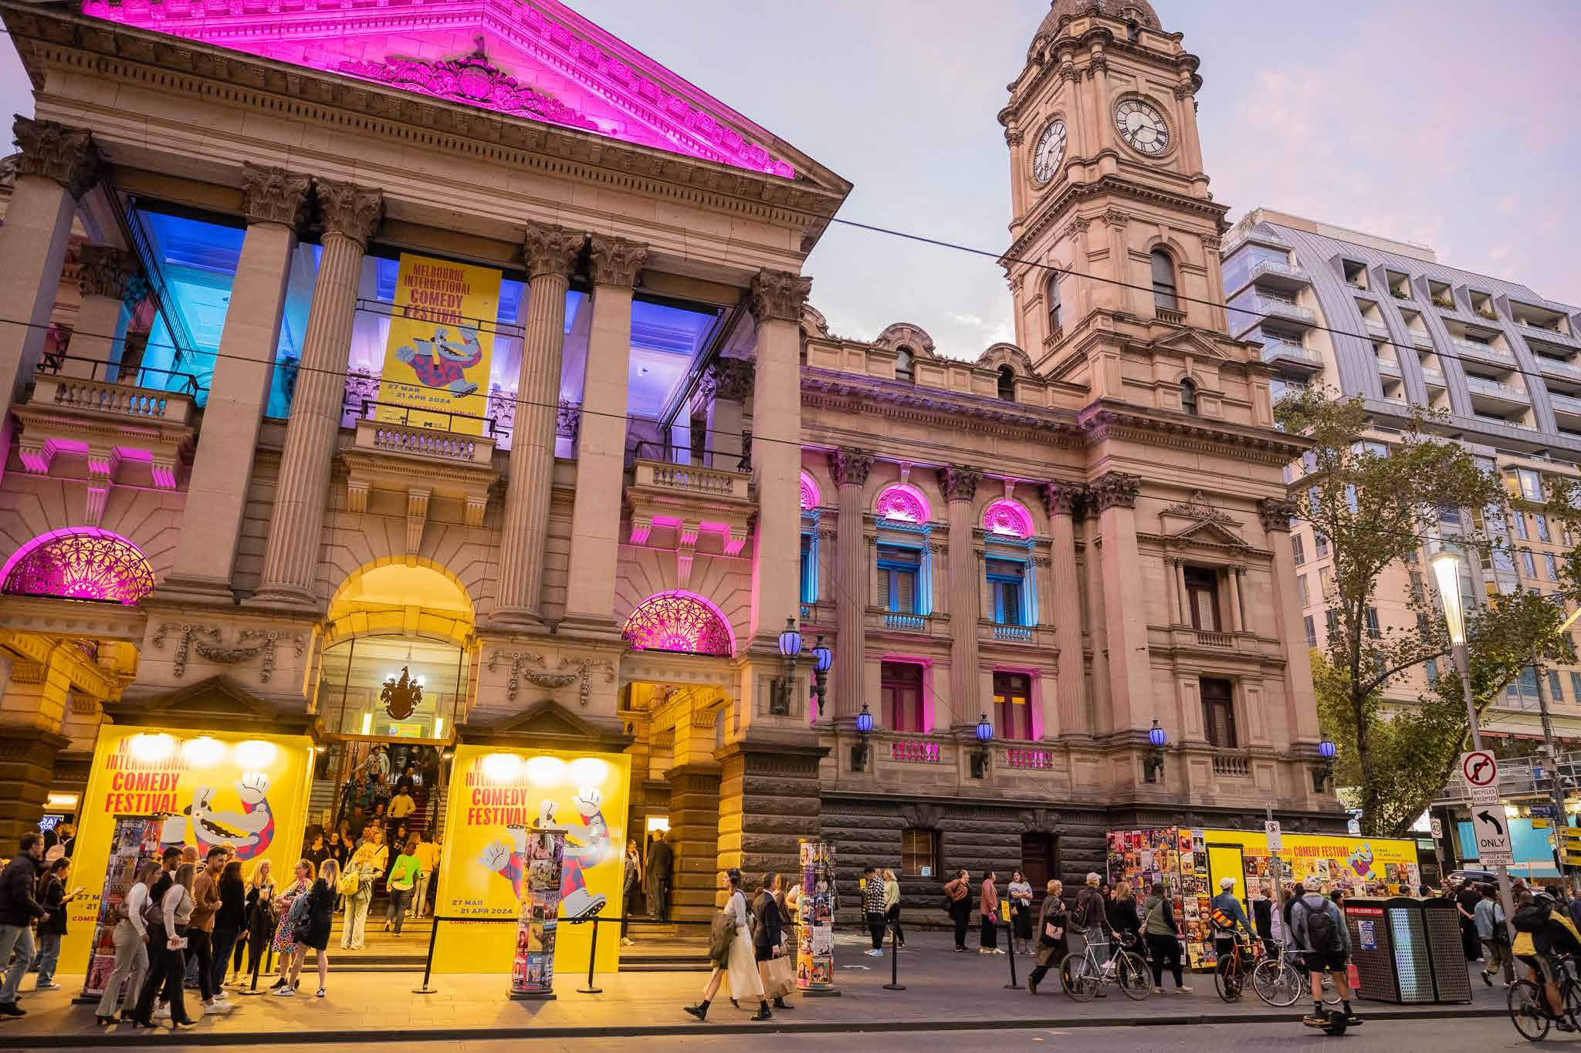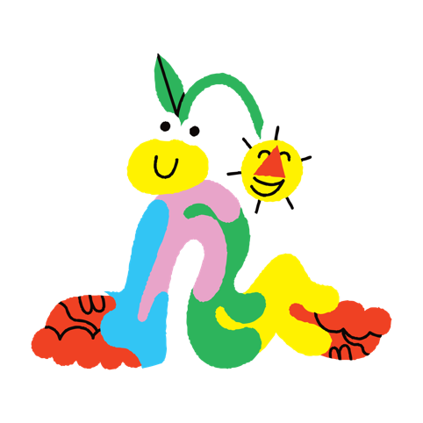

Melbourne Town Hall Social Stories
For shows during the Melbourne International Comedy Festival.

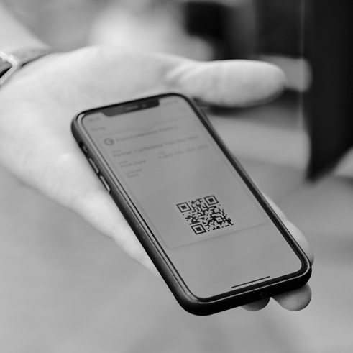
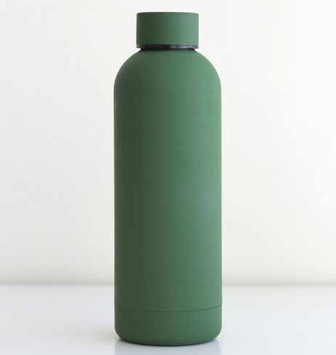
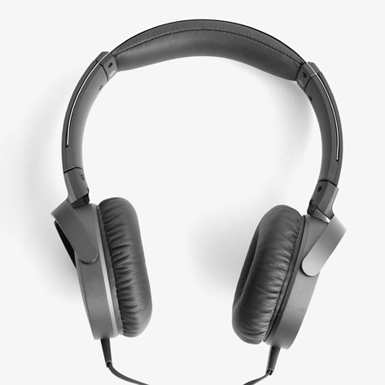
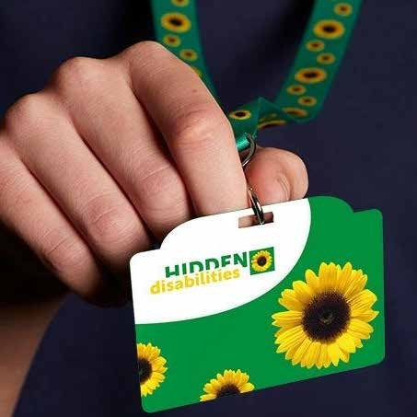
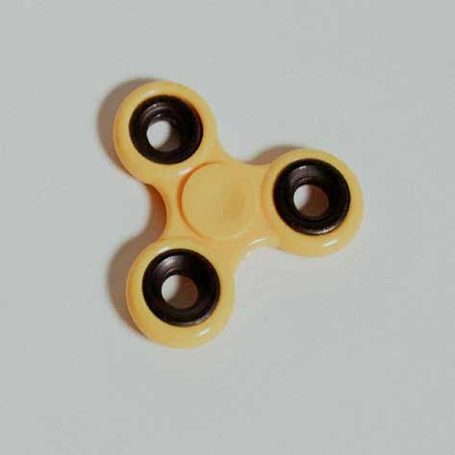

I must bring my ticket.
I can bring a water bottle.
I can bring headphones or ear plugs.
I can bring my sunflower lanyard.
I can bring
a fidget object that does not make much noise.

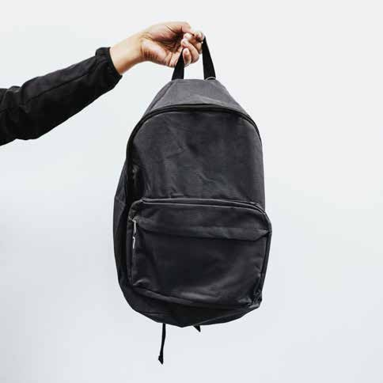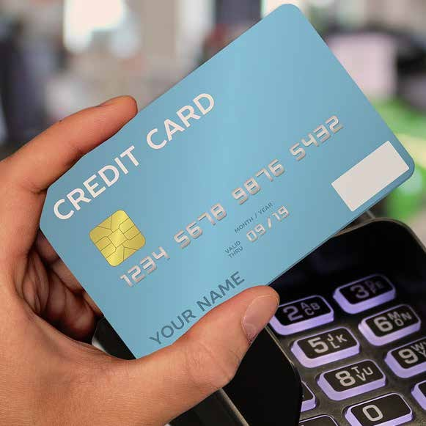

I can bring a small bag that can fit under my seat.
I can bring a debit or credit card to buy drinks at the bar.
I can not bring food or drinks other than water unless it is for a medical reason.

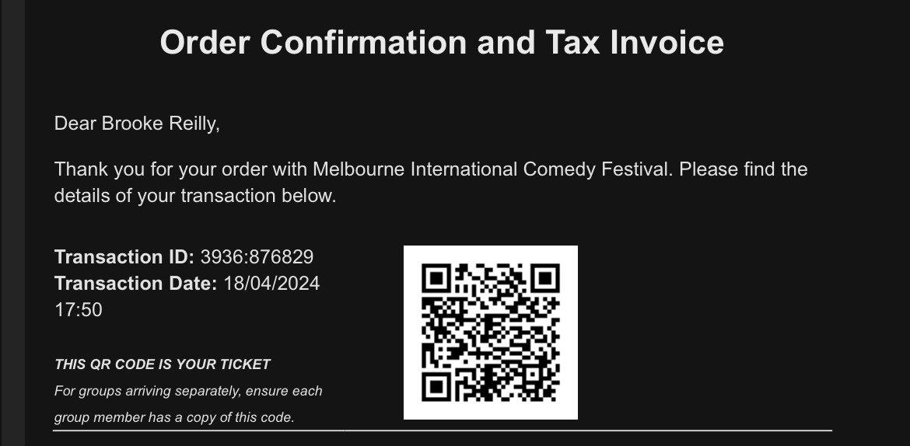
If I purchased my ticket, it will be in my emails. If someone else purchased my ticket, I will make sure they send the ticket to me before I go.
Jane Smith
1234:567890
I can bring my phone with the email. I can screenshot my ticket. I can print my ticket.

The address for Town Hall is 90-130 Swanston St Melbourne 3000. I can get to Town Hall by train, tram, or car.
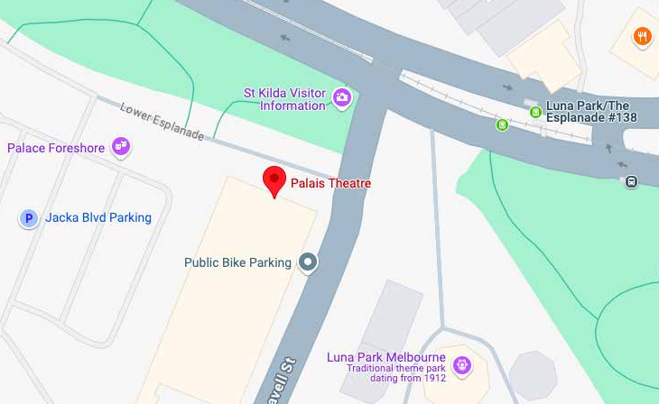
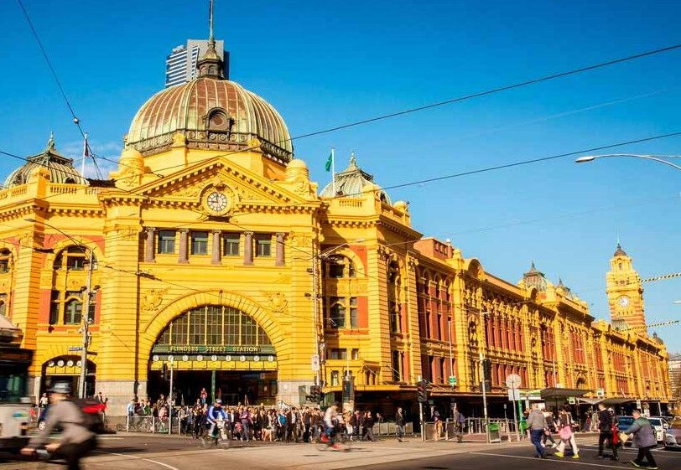
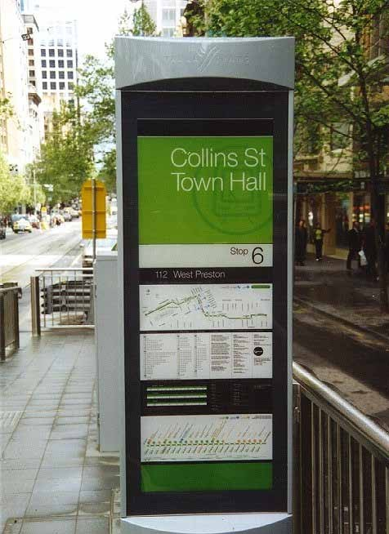
The closest train station is Flinders Street Station.
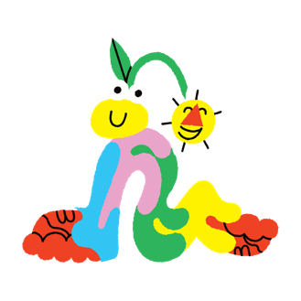
The closest tram stops are Stop 6 Collins Street, and Stop 10 Swanston St.

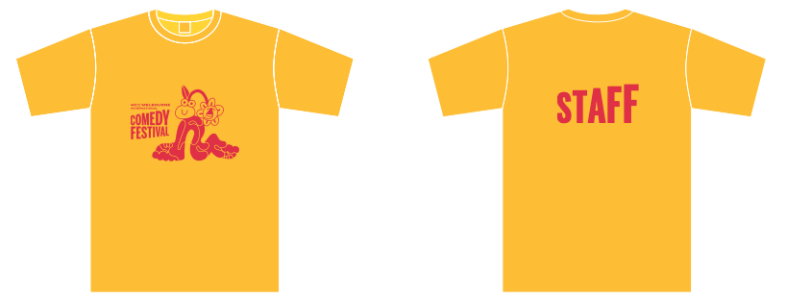
When I arrive, I will check my ticket for the correct door to enter and then join the queue.
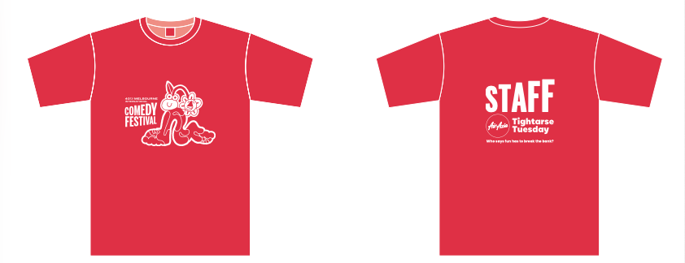
If I need help, I can ask a staff member. They are wearing yellow t-shirts (red on Tuesdays) and lanyards.

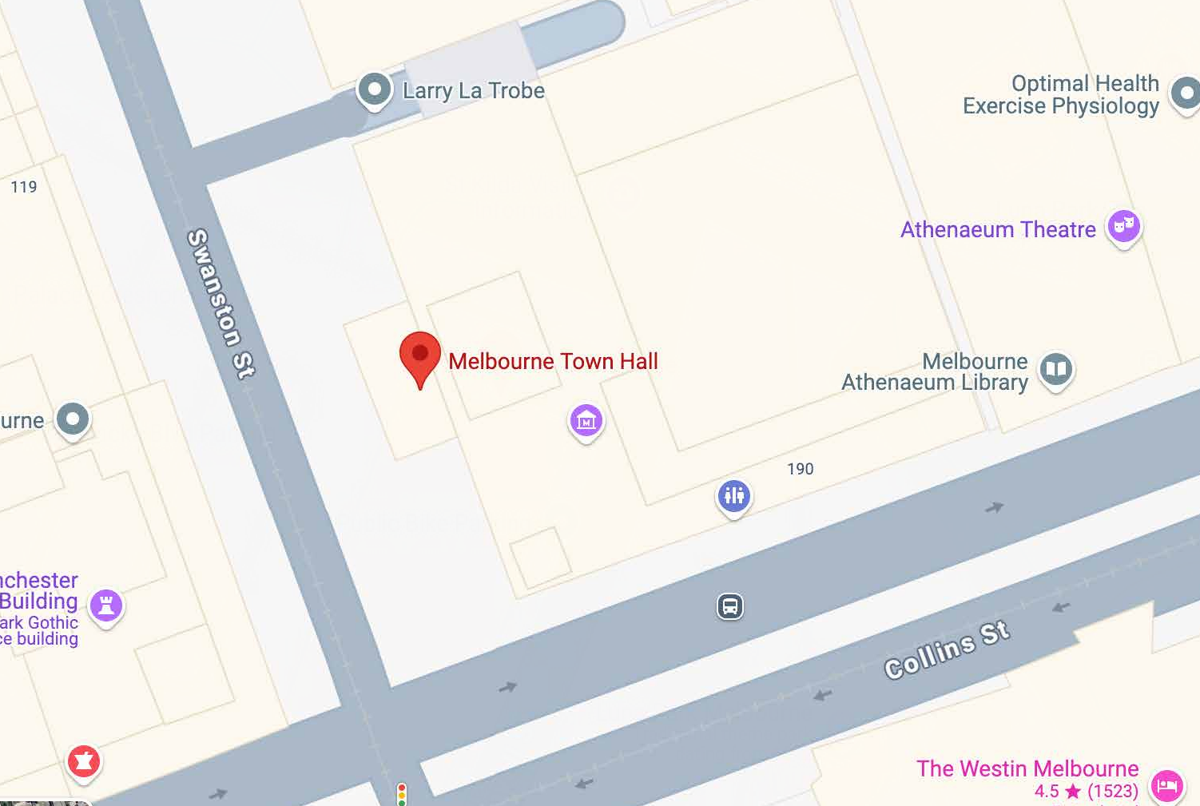
There are 3 entrances to Town Hall.
There are two entrances on Swanston Street.
There is one entrance on Collins Street.
If I’m not sure which entrance to use, I can ask a staff member for help.

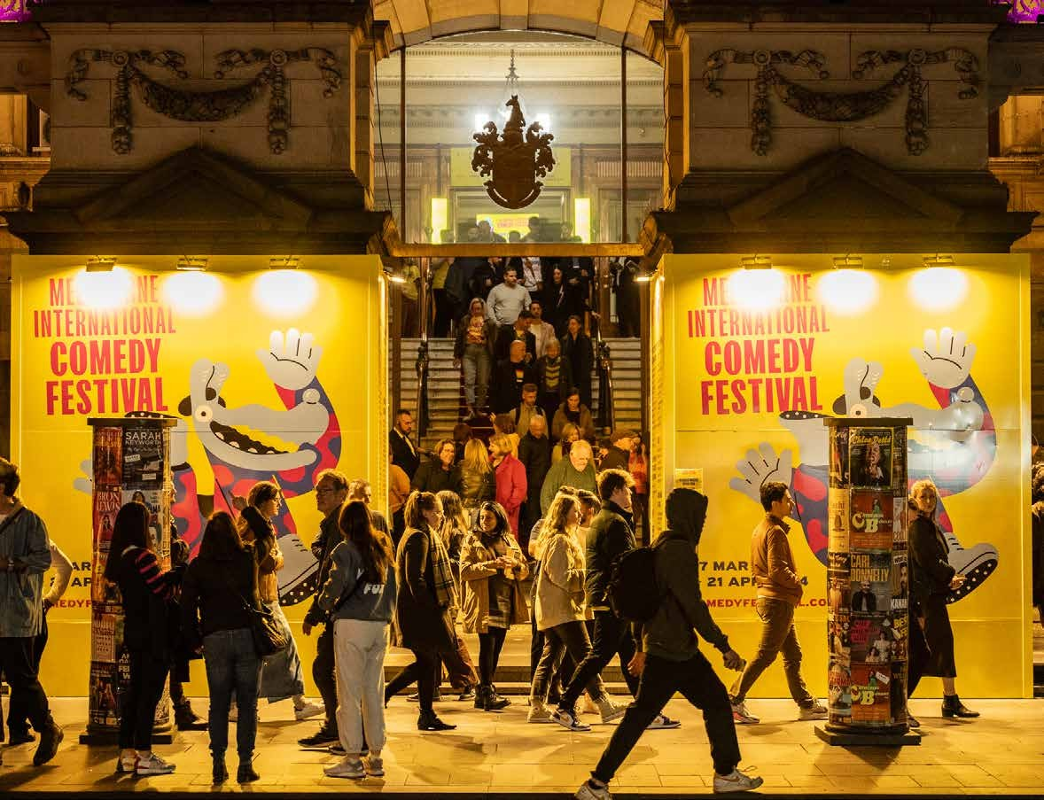
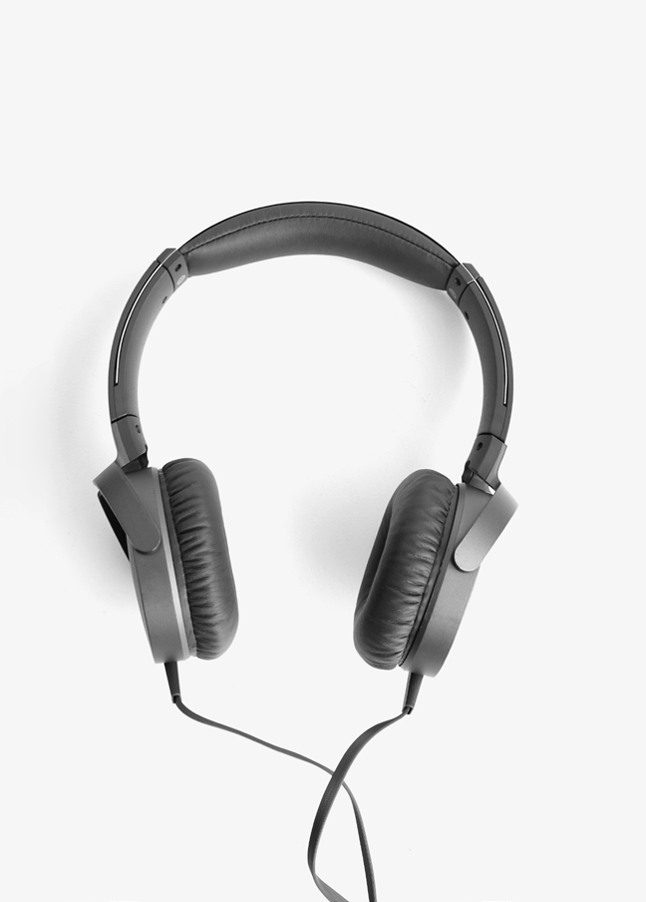
There may be lots of people outside Town Hall. It might be very loud and busy.
I can wear headphones or ear plugs if I want.

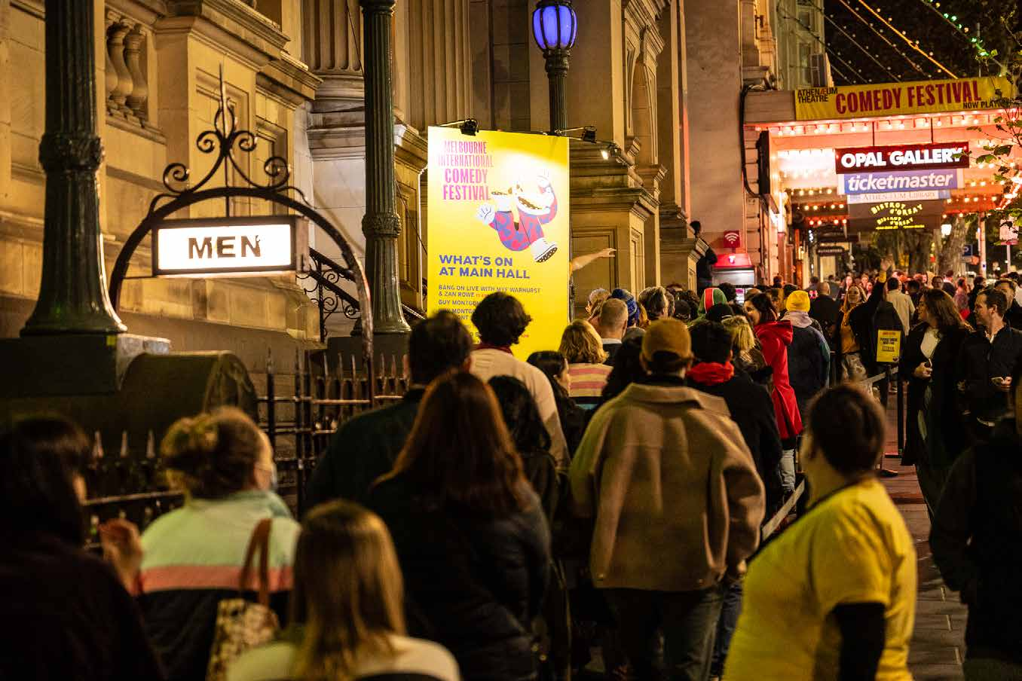
There will be someone at the door to scan my ticket before I enter.
I may need to wait in line to have my ticket scanned.

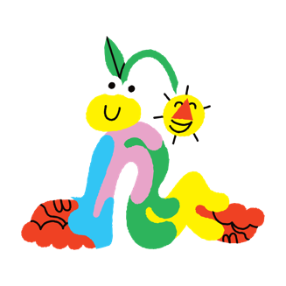

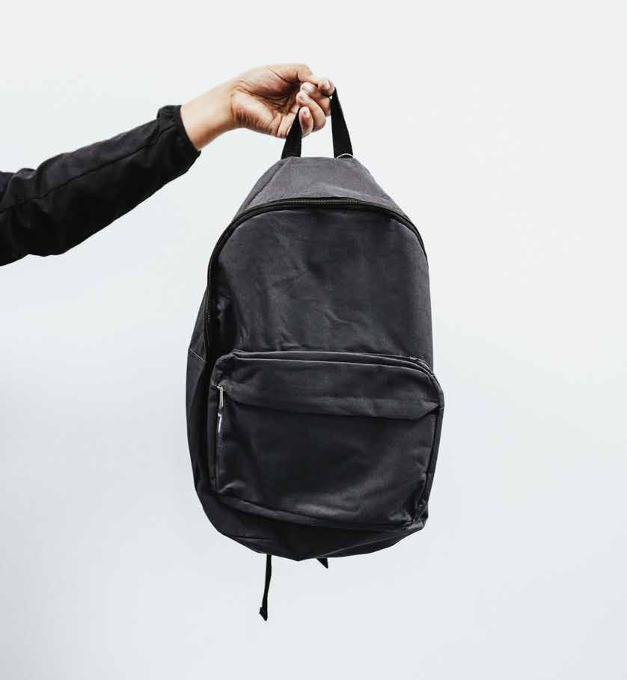
If I have a bag, I may be asked to open it by a security guard. This is to help keep everyone safe.

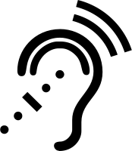
Melbourne Town Hall has assistive listening devices with headphones available that can be borrowed for shows in Main Hall and Lower Town Hall.
I can ask a staff member for help with assistive listening devices.

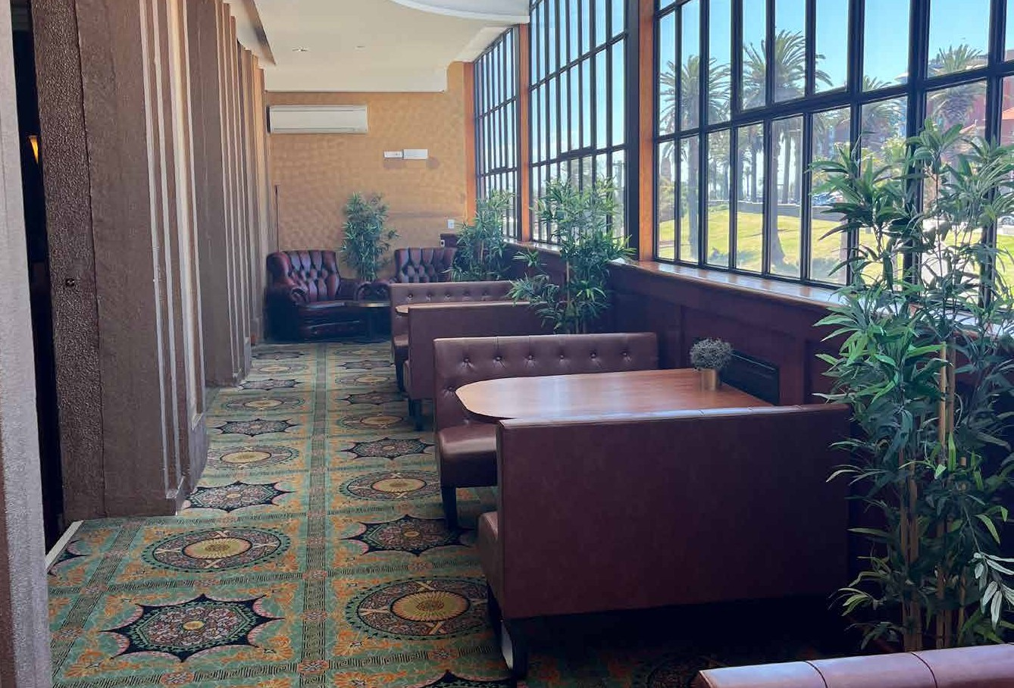
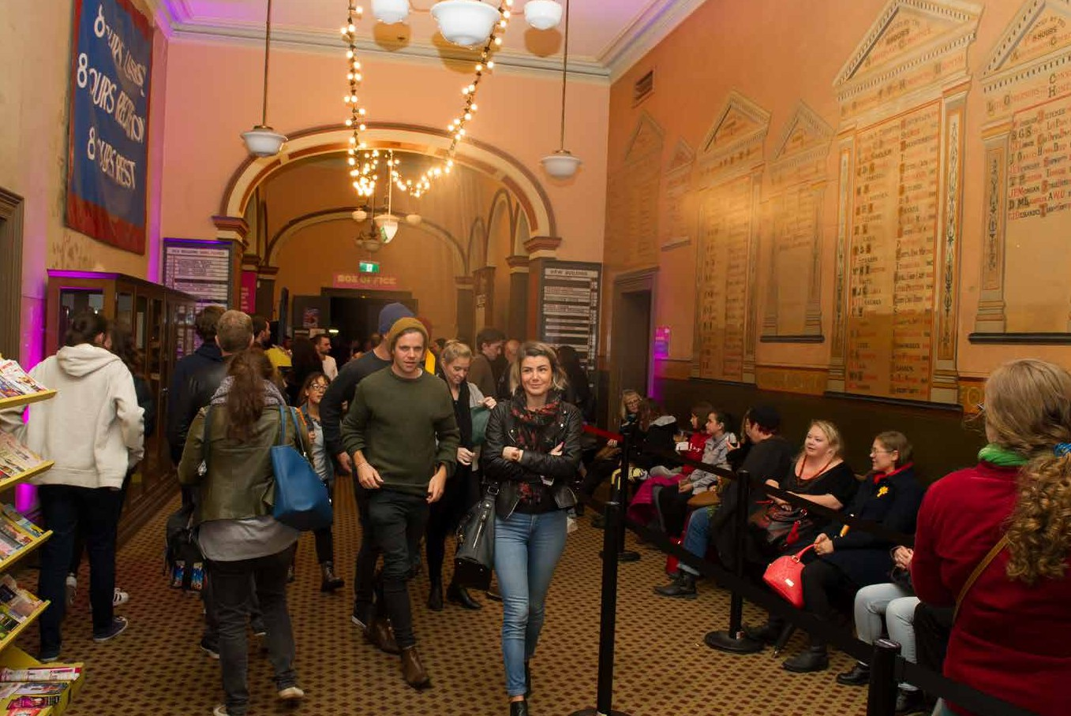
There may be lots of other people in the venue. It may be crowded and loud. There may be background music.
If I need to sit down, I can ask a staff member to help me find somewhere to sit.

There are bathrooms on the ground floor, first floor, and third floor.
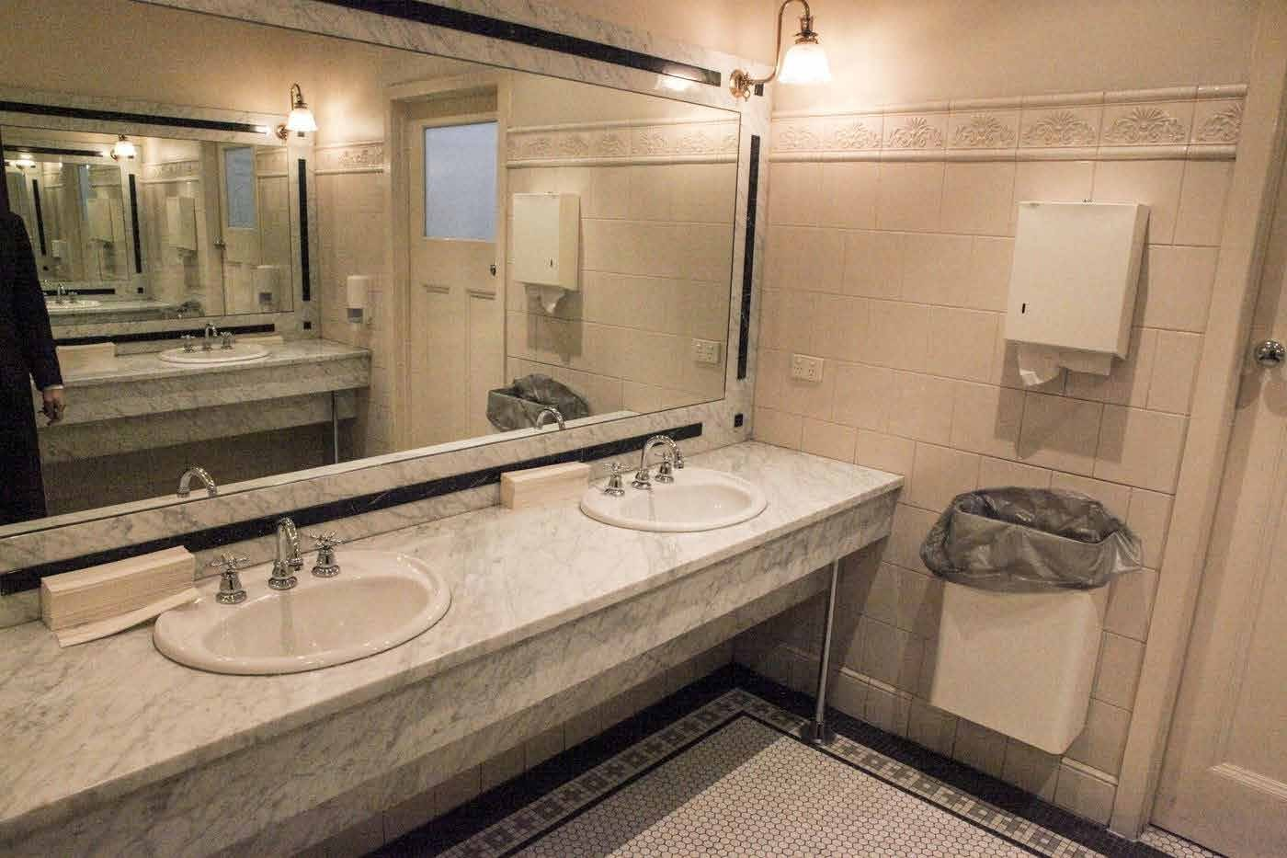
There are accessible bathrooms on the ground floor and the third floor. I can get to these using the lift.
If I need help finding a bathroom, I can ask a staff member.

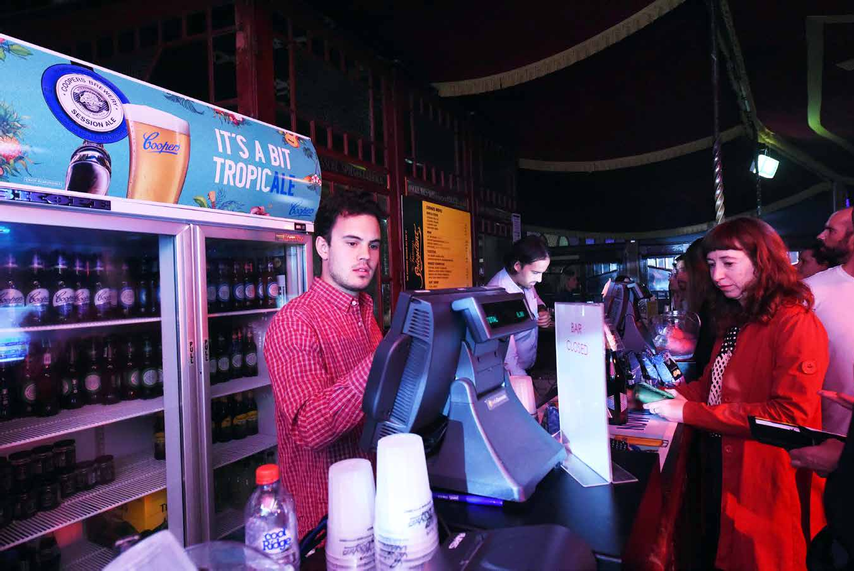
There are multiple bars throughout Town Hall. I can ask a staff member to show me where the closest one is.
There will be alcoholic and non-alcoholic drinks.
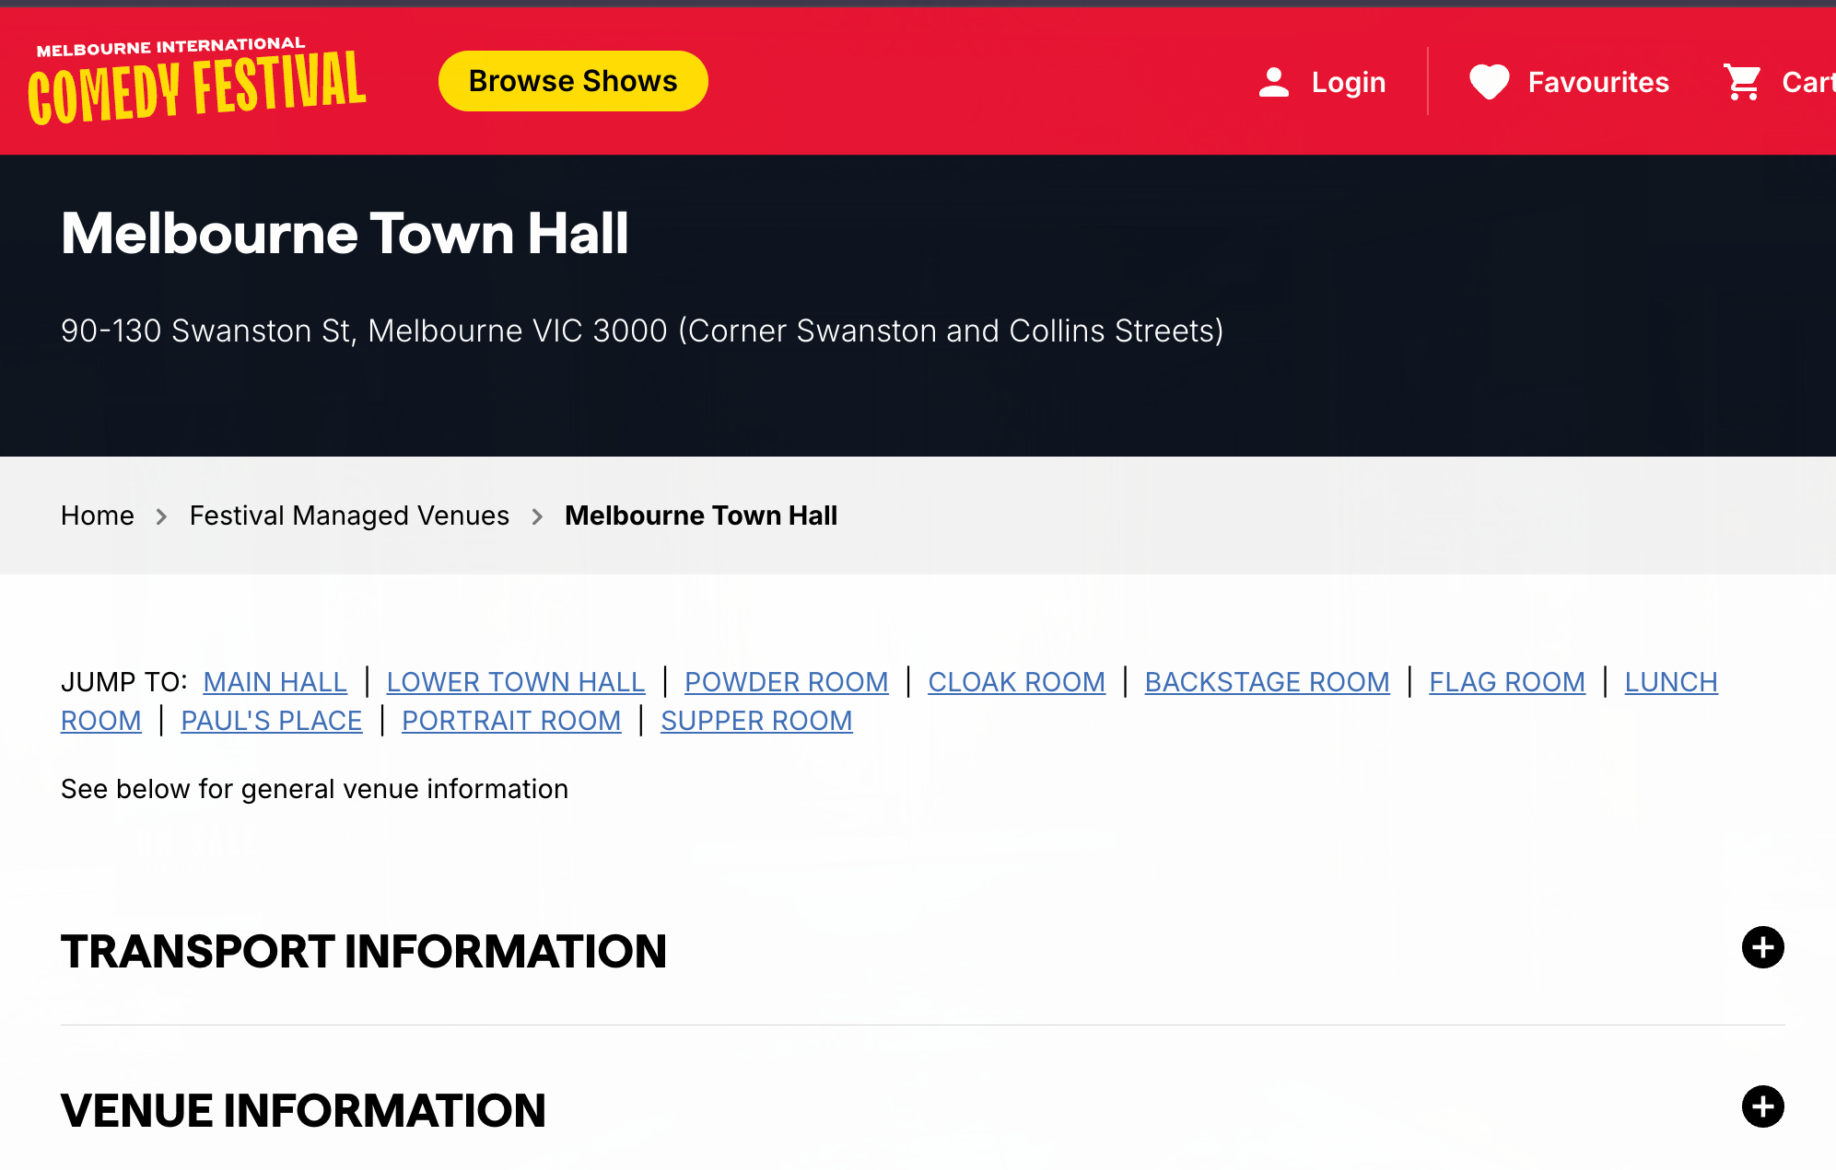
I can get water for free from beside the bar.

Each room at Town Hall is different. If I want to know more about the room I will be in, I can read about my room at this link: https://www.comedyfestival.com.au/festiv al-managed-venues/fmv-melbourne-town- hall/
I can also call 03 9245 3788 or email access@comedyfestival.com.au

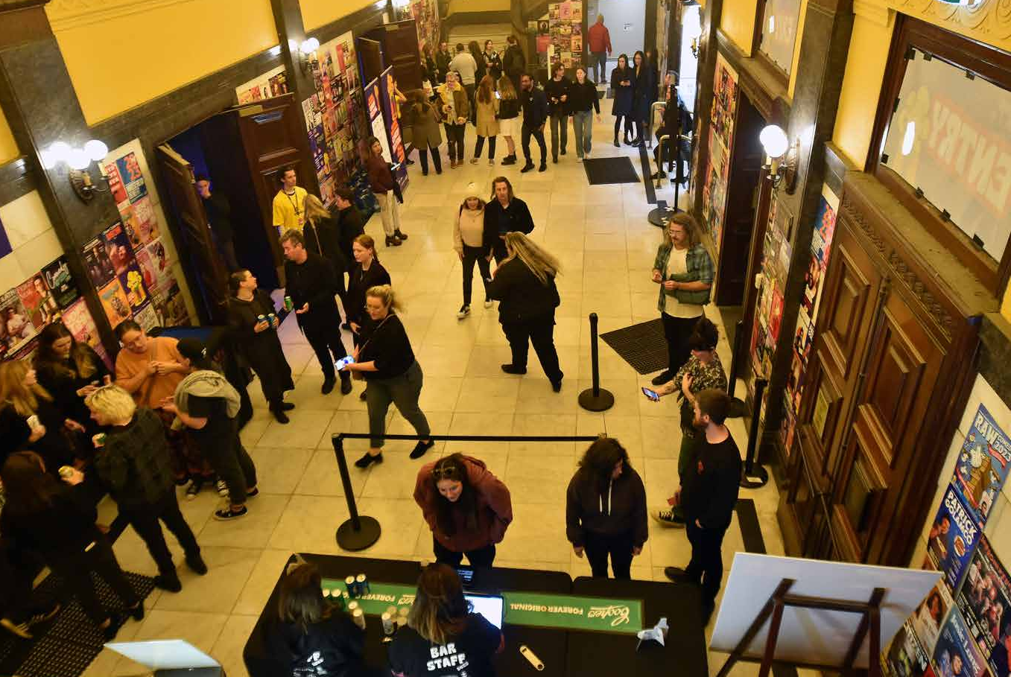
The doors to the theatre will open a few minutes before the show starts. It is different for every show.
I will try to be at the venue at least ten minutes before the show time on my ticket.

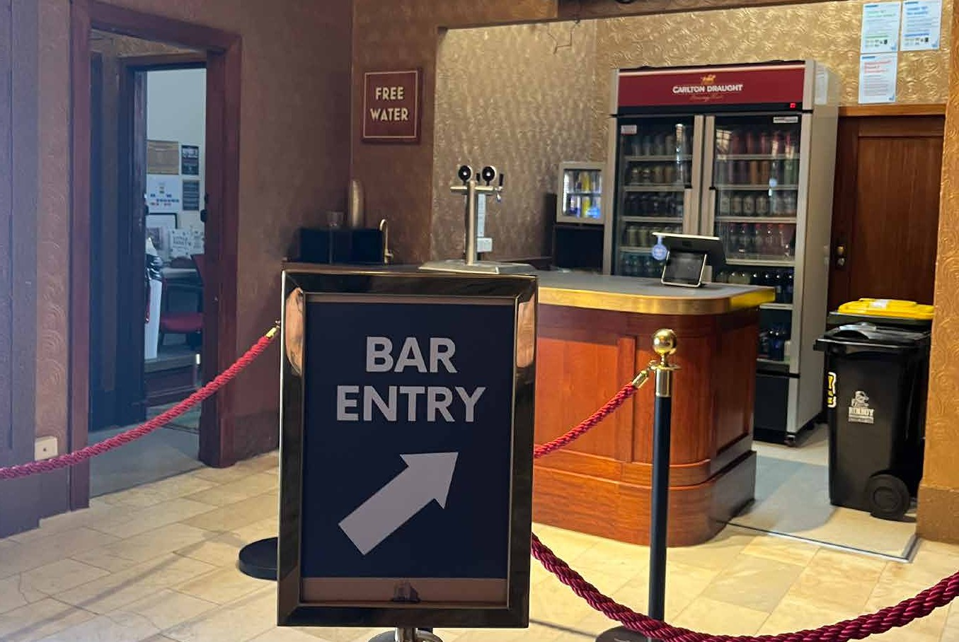
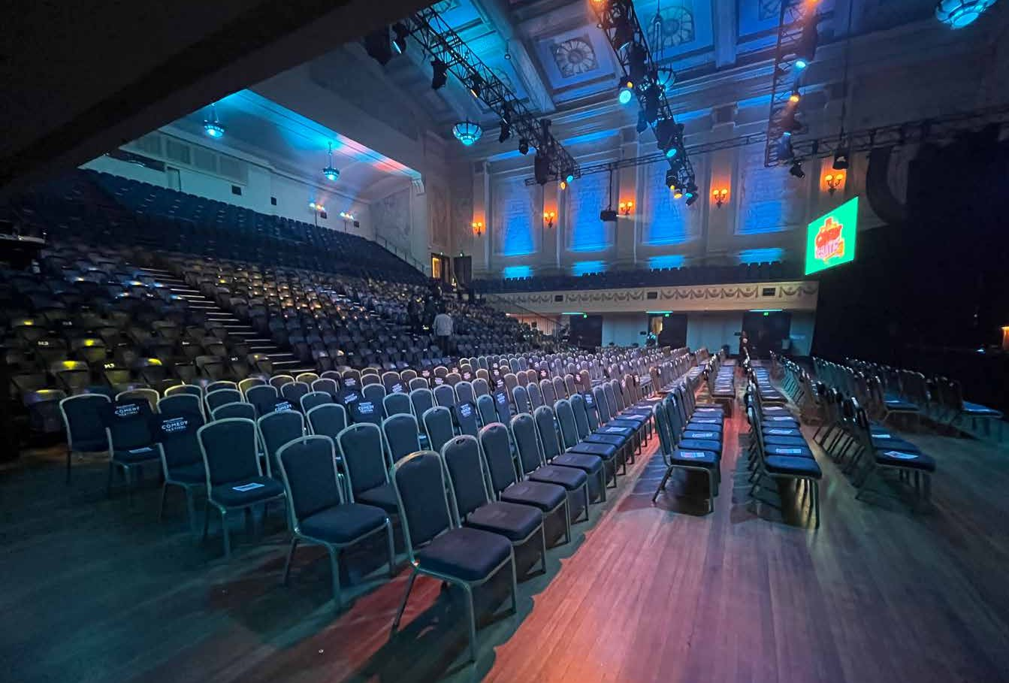
A staff member will check my ticket at the door, and let me in. If there are assigned seats, a staff member will tell me where to sit.
If there are no assigned seats, I can sit wherever I want, but I might get asked to sit somewhere specific by staff, especially if the room is not very full.

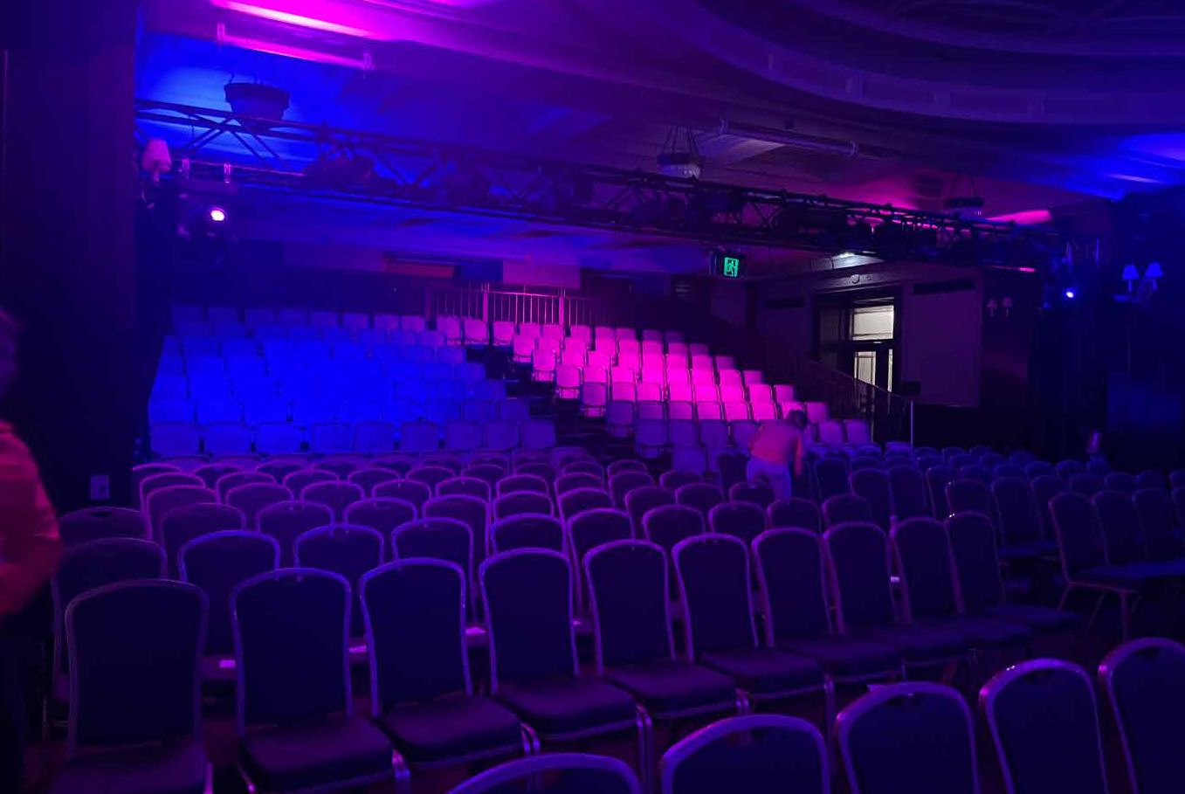
When I get into the room, there may be people talking, and there may be music playing.
There may be lights moving or shining towards me.

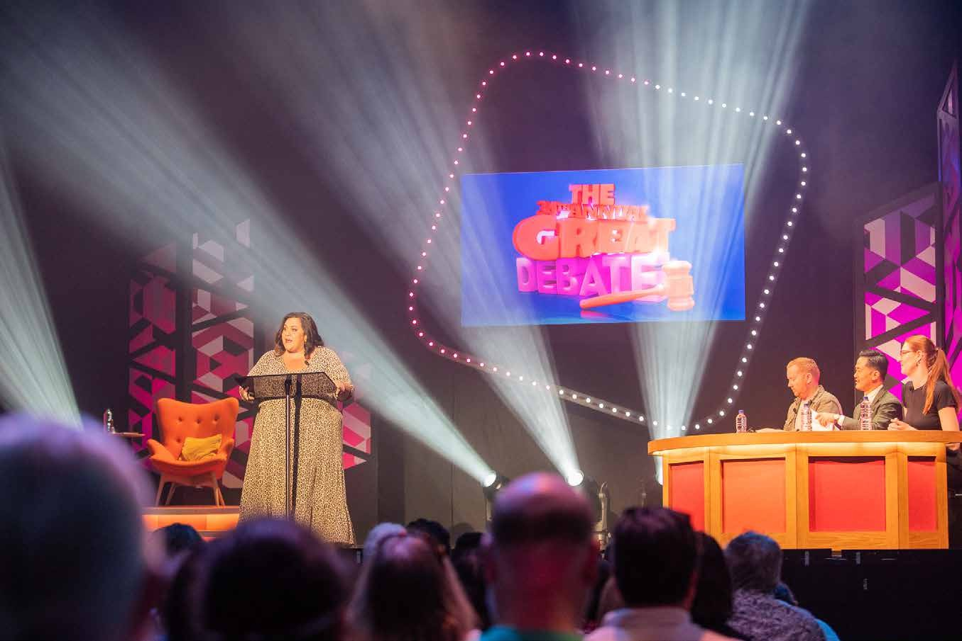
When the show is about to start, the ceiling lights will turn off and it will get darker.
When the show starts, there may be loud music that plays.
The artist will come out to start the show, and people may clap.

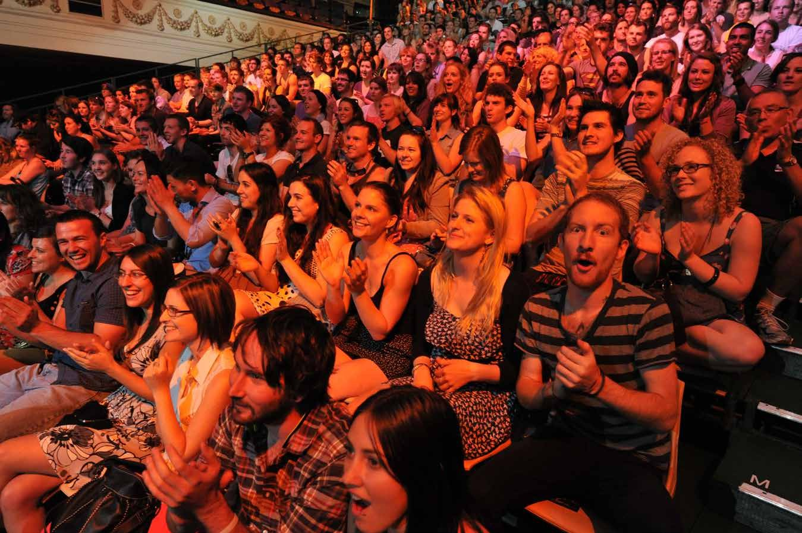
Throughout the show, I will hear lots of different jokes. There may be music or visual jokes as well.
Throughout the show people will laugh and clap. I can laugh and clap as well if I want too.

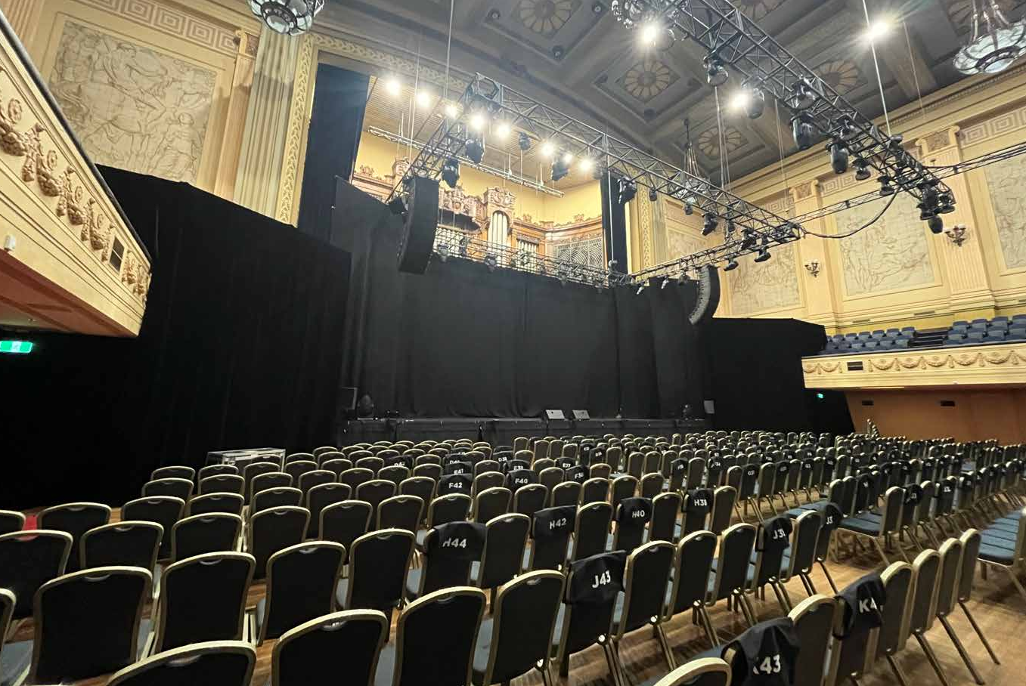

At the end of the show, the ceiling lights will come on, and it will be time to leave.
There will be lots of other people leaving at the same time as me.

