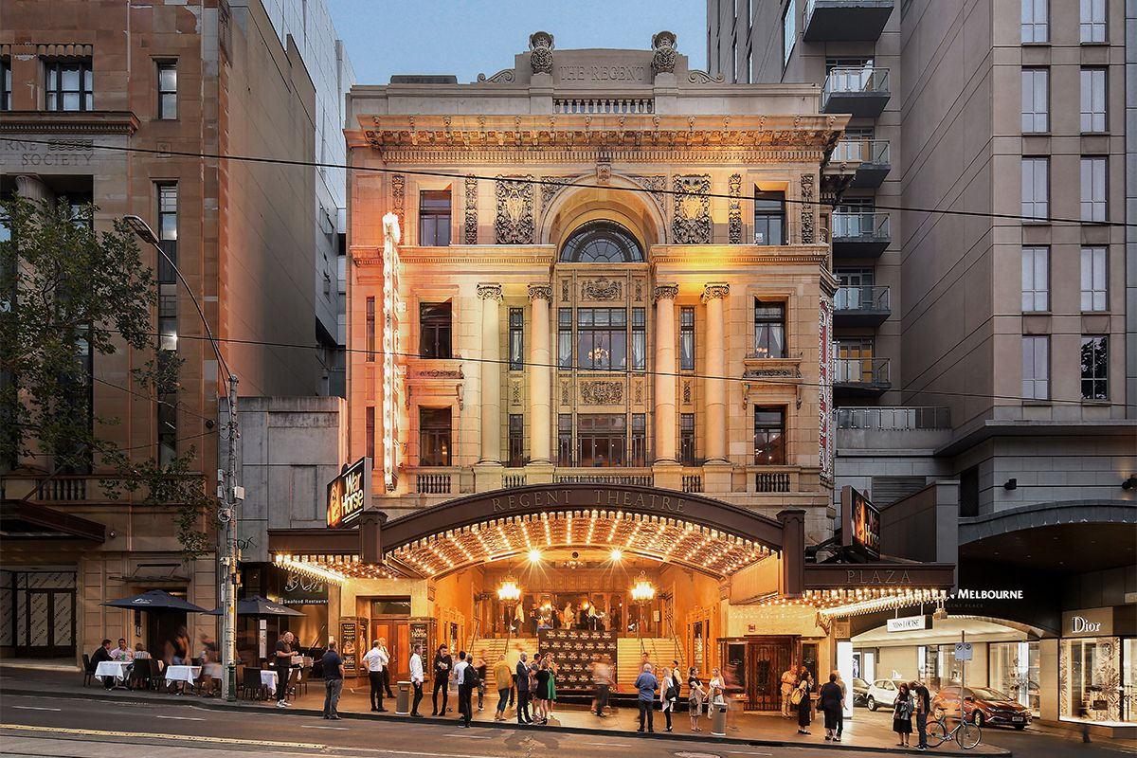

Regent Theatre Social Stories
For shows during the Melbourne International Comedy Festival

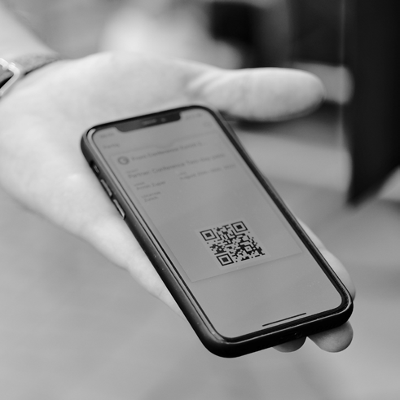
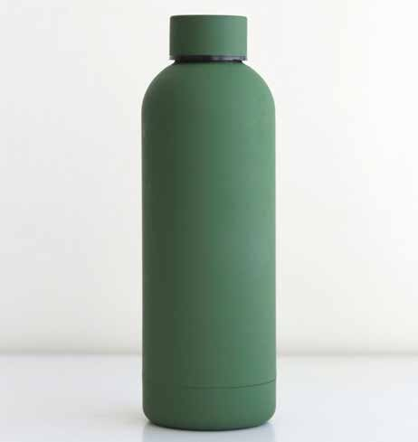
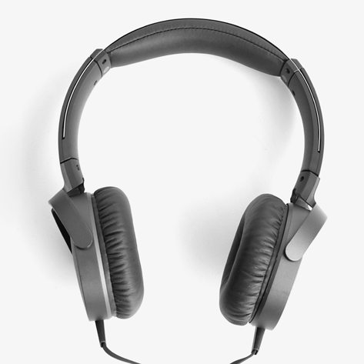
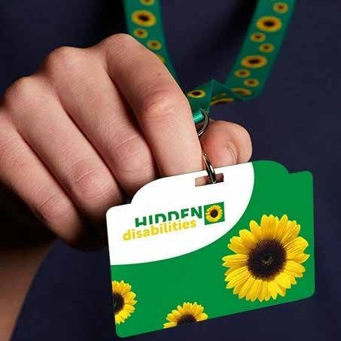


I must bring my ticket.
I can bring a water bottle.
I can bring headphones or ear plugs.
I can bring my sunflower lanyard.
I can bring
a fidget object that does not make much noise.


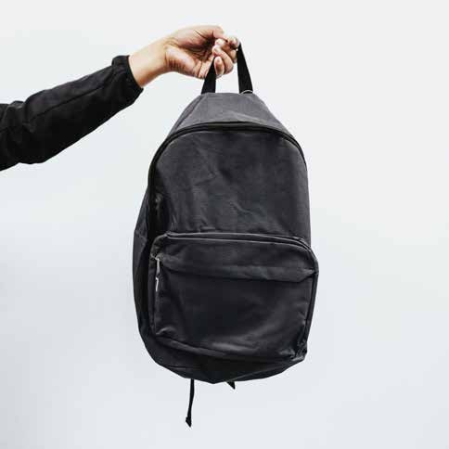

I can bring a bag smaller than A4 size.
I can bring a debit or credit card to buy drinks at the bar.
I can not bring food or drinks other than water unless it is for a medical reason.

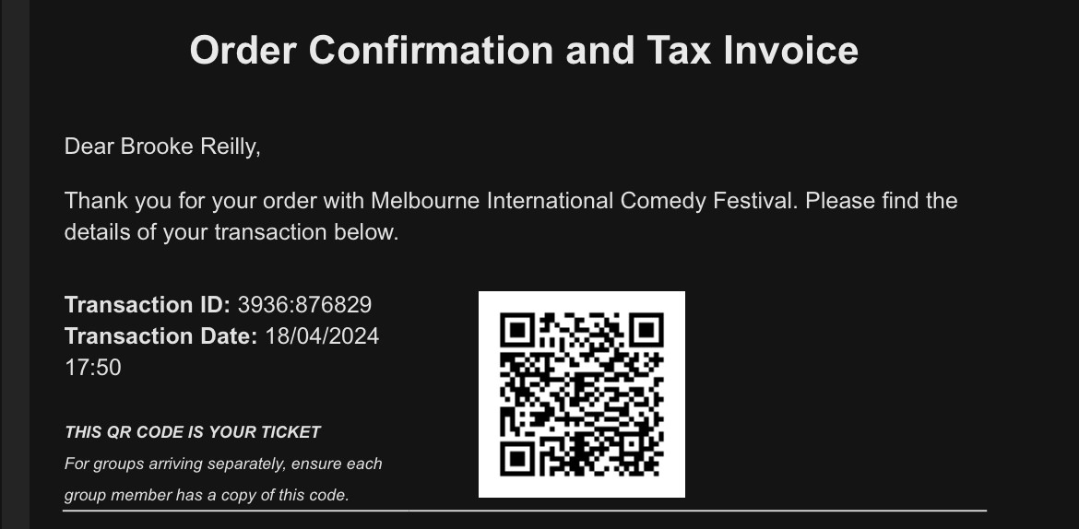
If I purchased my ticket, it will be in my emails. If someone else purchased my ticket, I will make sure they send the ticket to me before I go.
Jane Smith
1234:567890
I can bring my phone with the email. I can screenshot my ticket. I can print my ticket.

The address for Regent Theatre is 191 Collins St Melbourne 3000. I can get to Regent Theatre by train, tram, or car.
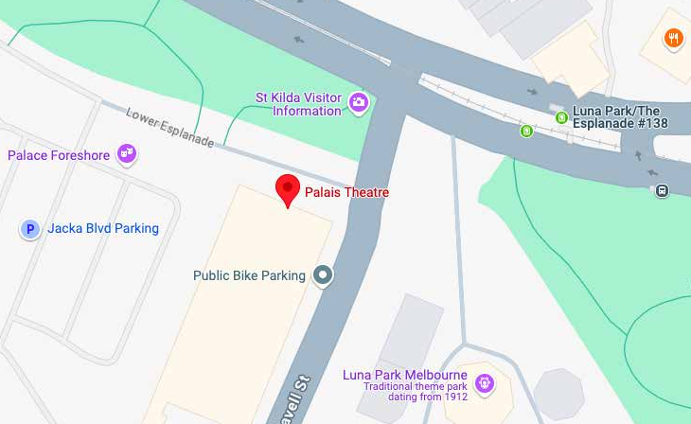
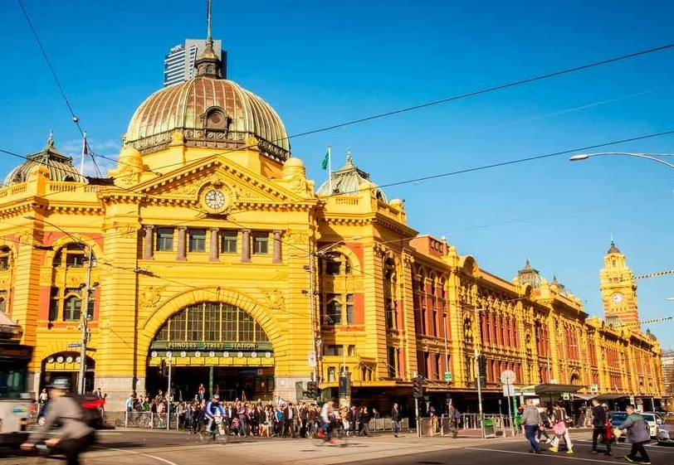
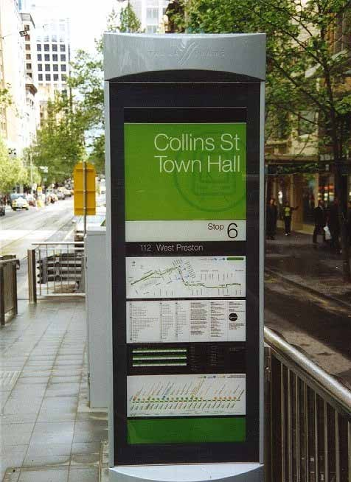
The closest train stations are Flinders Street Station and Town Hall Station.
The closest tram stops are Stop 6 Collins Street, and Stop 11 Swanston St.

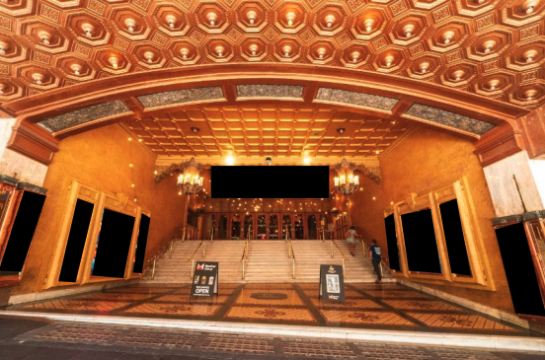
There are 14 steps up to the main entrance. I can ask a staff member for lift access.
There will be someone at the door to scan my ticket before I enter.
I may need to wait in line to have my ticket scanned.

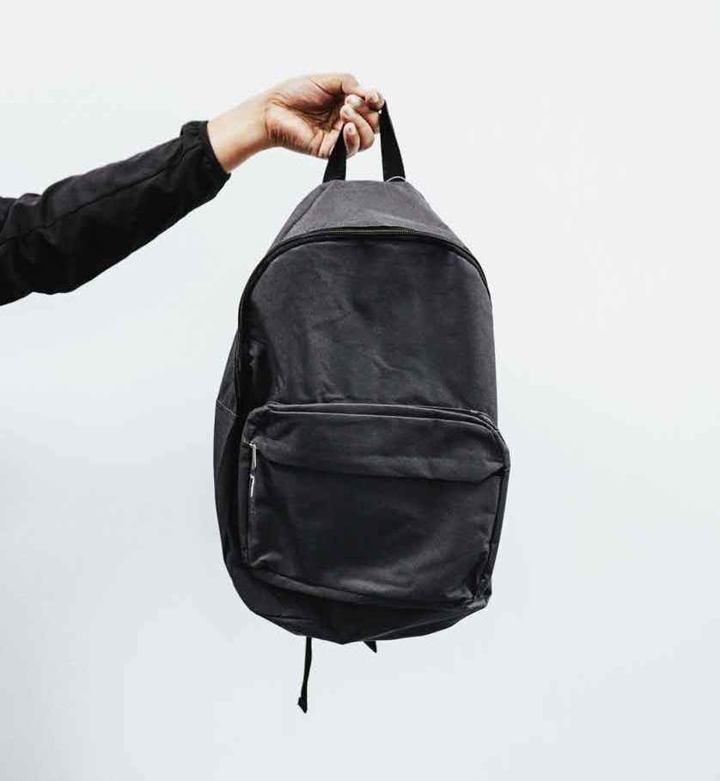
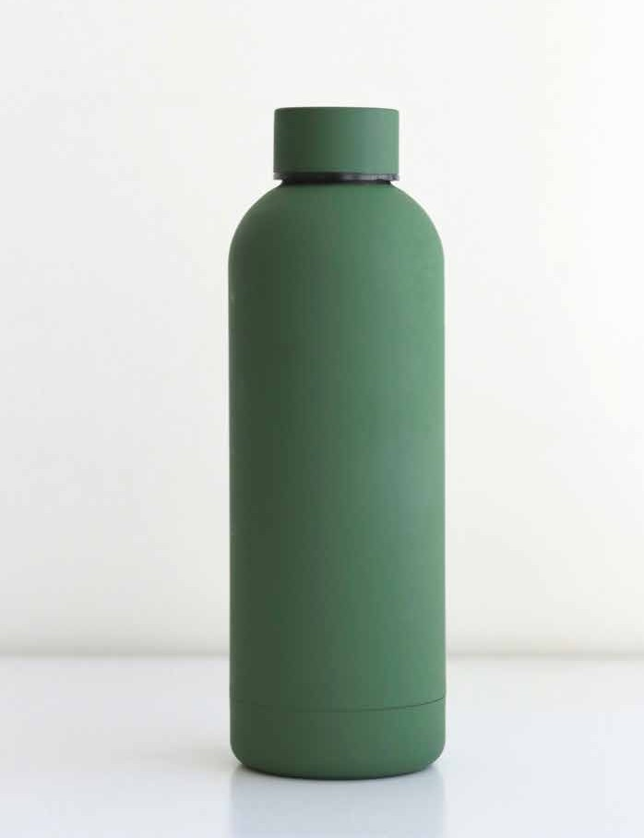
If I have a bag, I may be asked to open it by a security guard. This is to help keep everyone safe. I can put large bags in the Cloakroom.

If I have a bottle, I may need to empty it. I will be able to refill it with water at the bar.

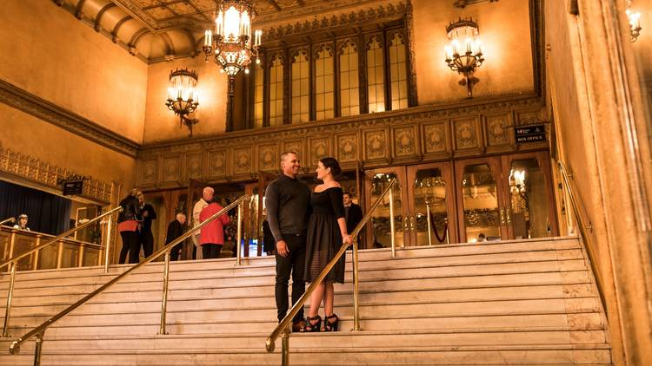
Doors to the theatre open approximately one hour before the show. I will try to be at the venue at least thirty minutes before the show time on my ticket.
I will have my ticket ready for a staff member to scan when I enter.


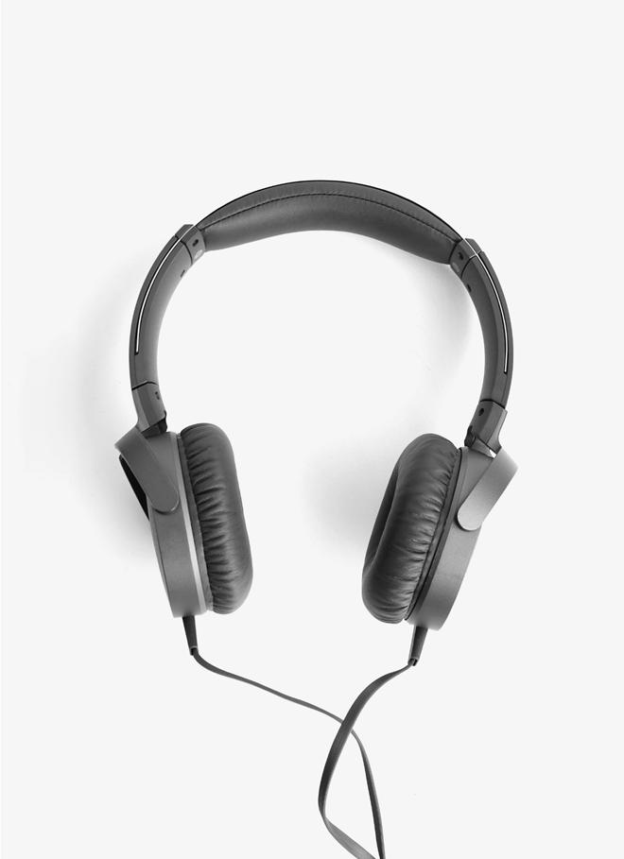
There may be lots of people outside Regent Theatre. It might be very loud and busy.
I can wear headphones or ear plugs if I want.
If I need help, I can ask a staff member. They will be wearing all black clothes and name tags.

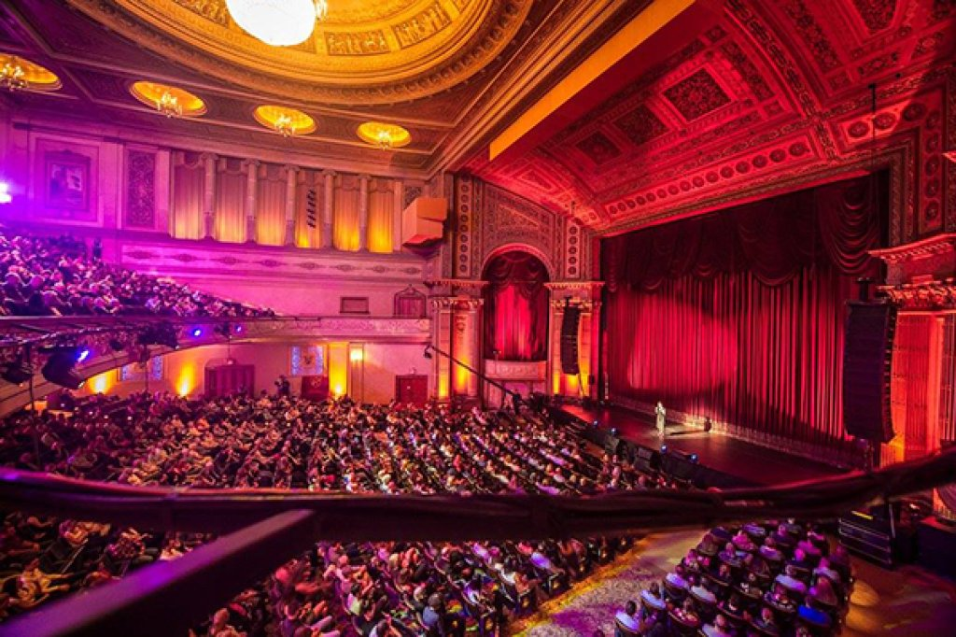

There may be lots of other people in the venue. It may be crowded and loud. There may be background music.
If I need to sit down, I can ask a staff member to help me find somewhere to sit.

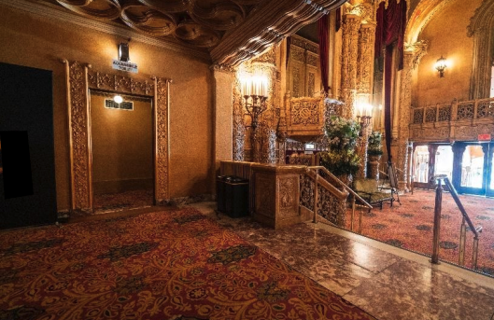
There are toilets I can use on the Stalls and Dress Circle levels.

There is a gender neutral and accessible toilet is in the Stalls foyer I can use.

I can ask staff for directions if needed.

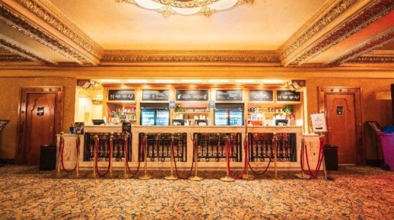
There are multiple bars throughout the Regent Theatre. I can ask a staff member to show me where the closest one is.
There will be alcoholic and non-alcoholic drinks.


The Regent Theatre has assistive listening devices available that can be borrowed from the Cloakroom in the Stalls Foyer that I can use if I need.
I can ask a staff member for help with an assistive listening device.
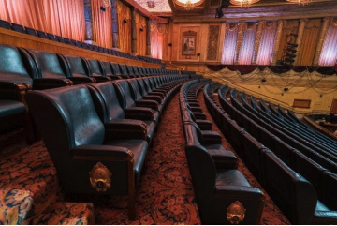
My ticket will have which level I am sitting on, and the row and seat number.
When I enter the theatre, a staff member will tell me where to go.

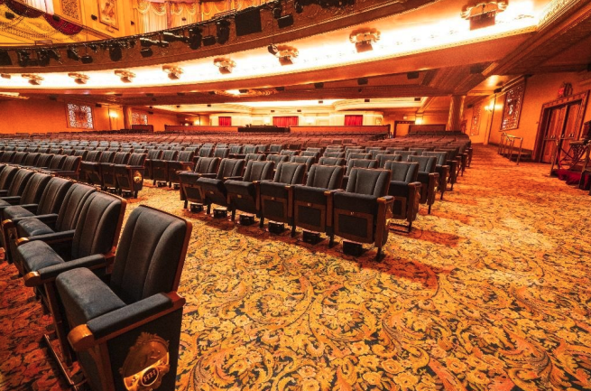
The theatre is in a big hall with lots of seats.
There will be background music playing, and people may be talking.
The stage will have a large set that may light up. There will be lots of lights that may shine towards me, and may move around.
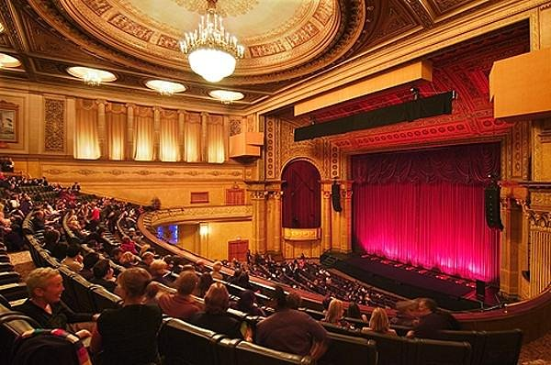
The performance will be recorded for television, so there will be large cameras.
There will also be a large crane with a camera on the end that moves around.
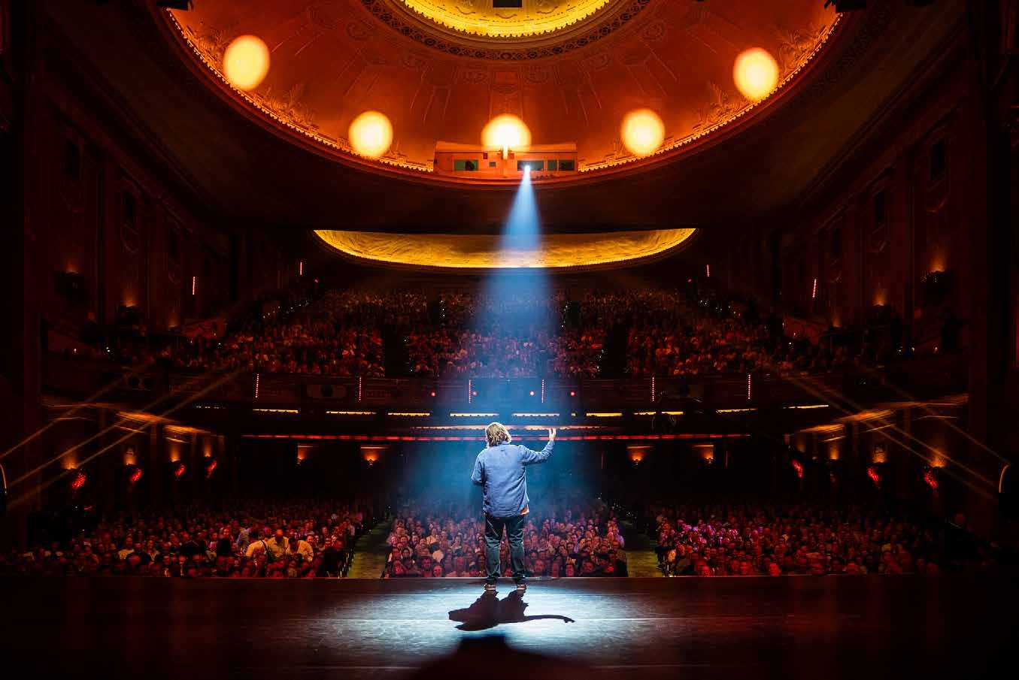
If being near the cameras or camera crane worries me, I can speak to an usher and ask them to find me another seat.

When the show is about to start, the ceiling lights will turn off, and it will get darker.
A warm-up act will come on stage and explain how the show will run. They may ask me to applaud and cheer with everyone else. This is so that the filming crew can get footage of people cheering.
If I’m unsure, I can sit still.

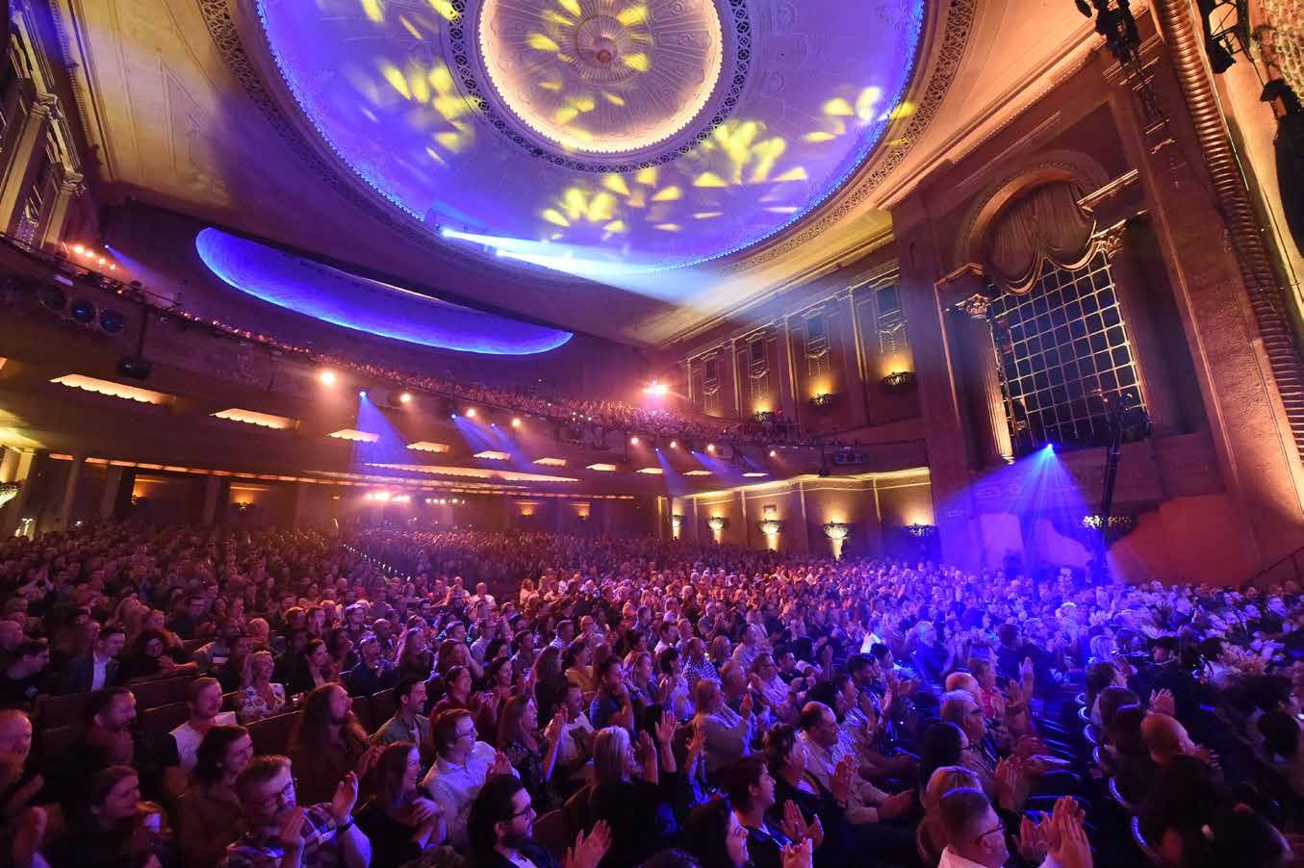
After the warm-up act finishes, the show will start.
Loud music will play, and the lights will flash and move around.
The host will come out to start the show, and people will clap. They will tell some jokes, and then introduce the next act.

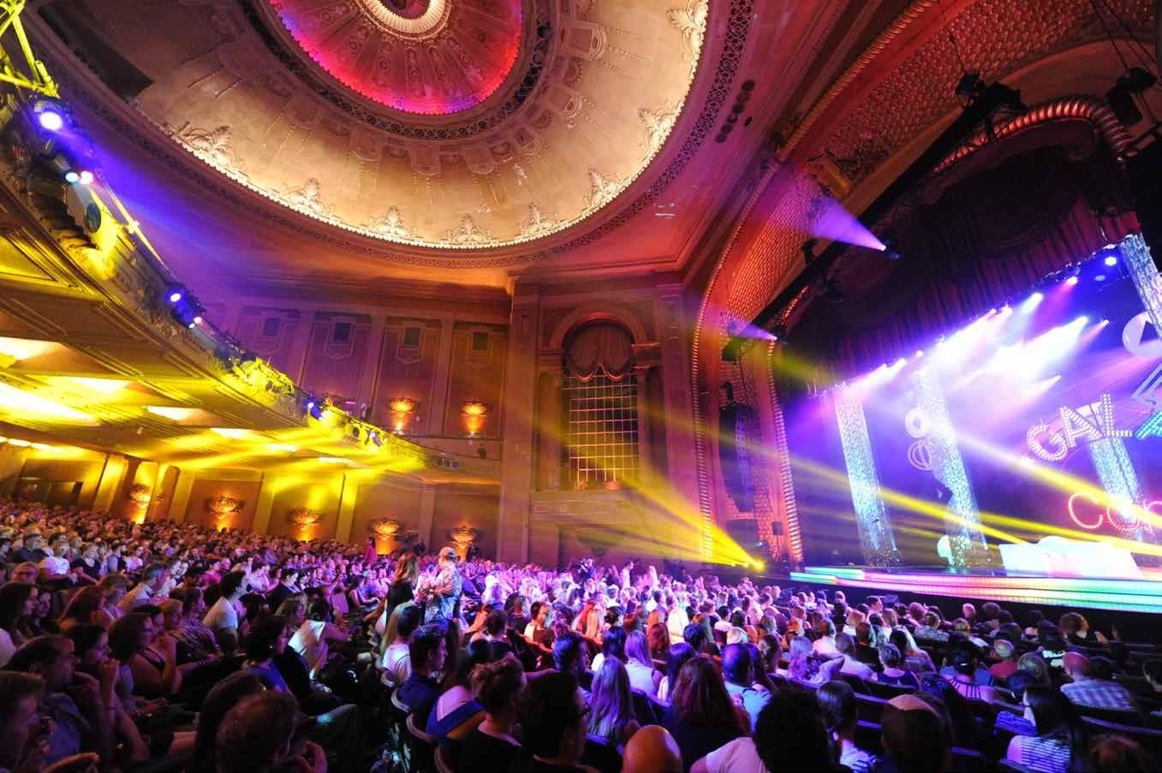
Throughout the show, I will see lots of different performers.
They will all tell different kinds of jokes, and people will laugh and clap. I can laugh and clap as well if I want too.

I may recognise some performers, and I may discover some new performers.

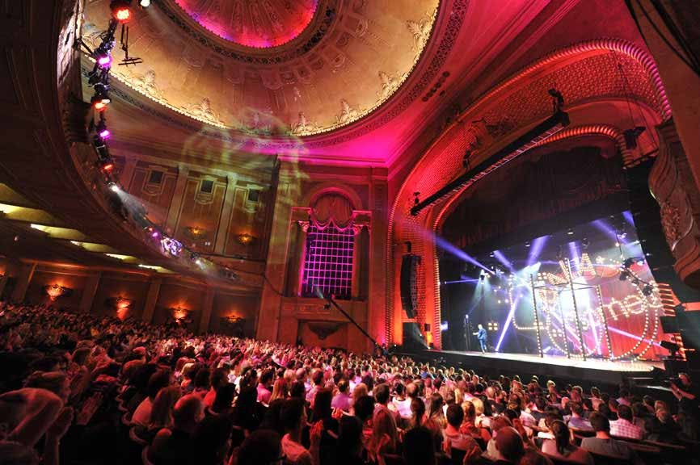
There will be a break in the middle of the performance called an intermission.
The ceiling lights will come on during the intermission, and I can get out of my seat and go to the toilet or to the bar.
There will be an announcement over the speakers when the intermission is over, and I will go back to my seat.

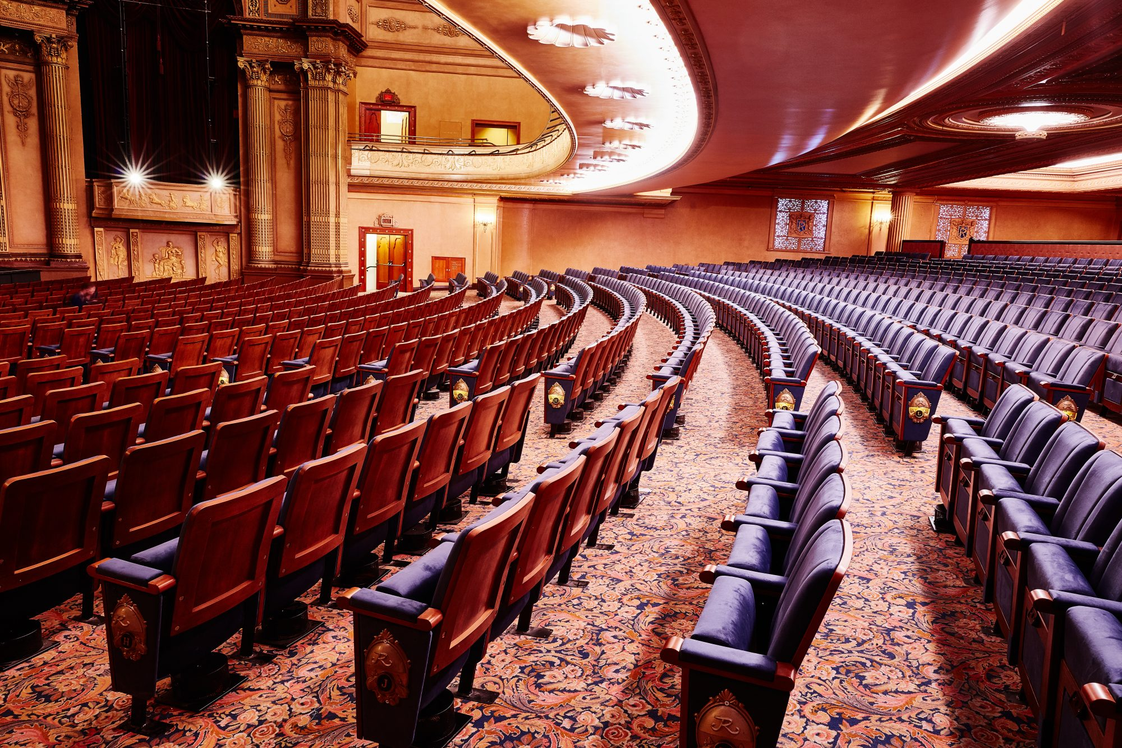

At the end of the show, the ceiling lights will come on, and it will be time to leave.
There will be lots of other people leaving at the same time as me.
