

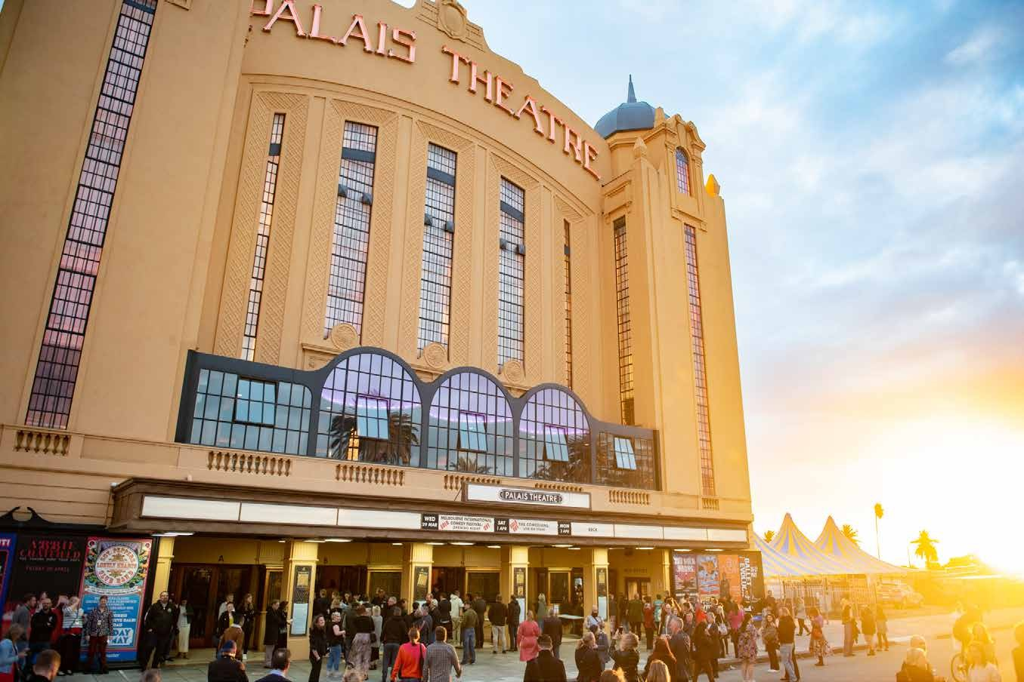
Social Stories
For the Melbourne International Comedy Festival Gala and Opening Night Comedy Allstars Supershow at the Palais Theatre

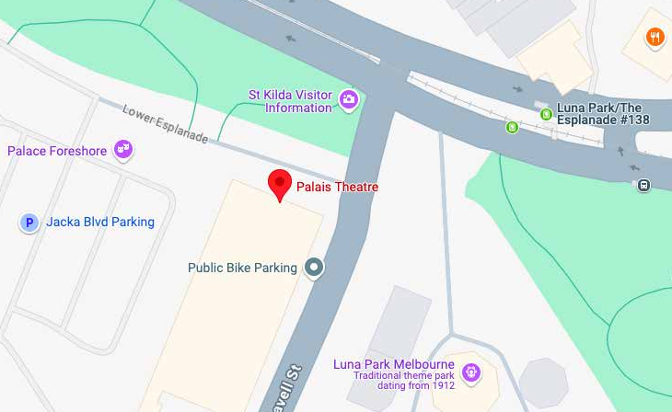
Entry to the Palais Theatre is from Lower Esplanade.

I can get to the Palais Theatre by car, tram, bus, or train. I will figure out the best way to get there before I go, and leave with plenty of time so that I’m not late.

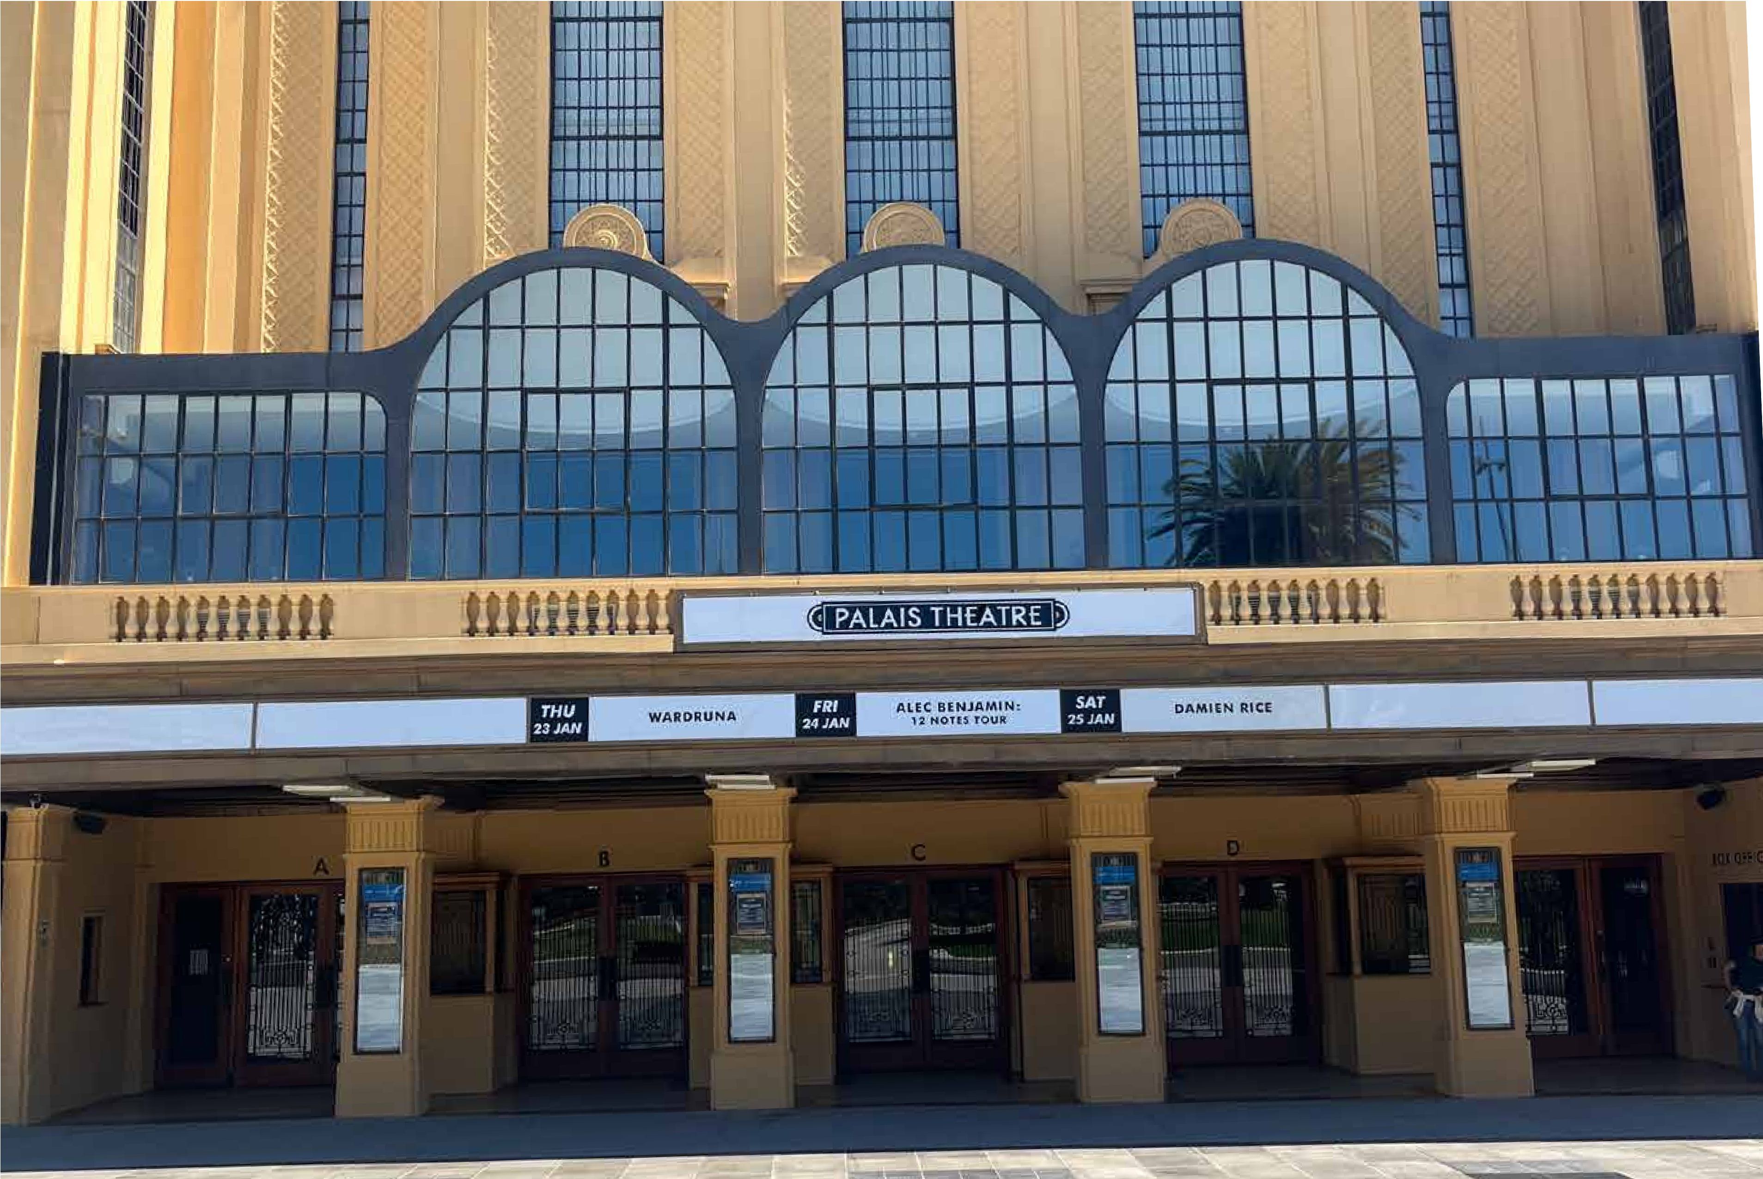
I can enter through the large main doors.
There will be someone at the door to scan my ticket before I enter.
I may need to wait in line to have my ticket scanned.

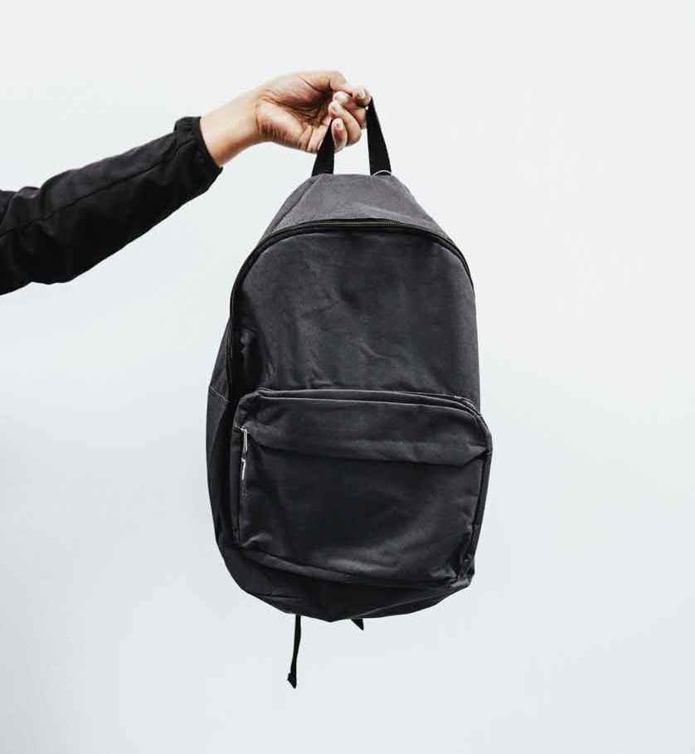

If I have a bag, I may be asked to open it by a security guard. This is to help keep everyone safe.
If I have a bottle, I may need to empty it. I will be able to refill it with water at the bar when I am inside.

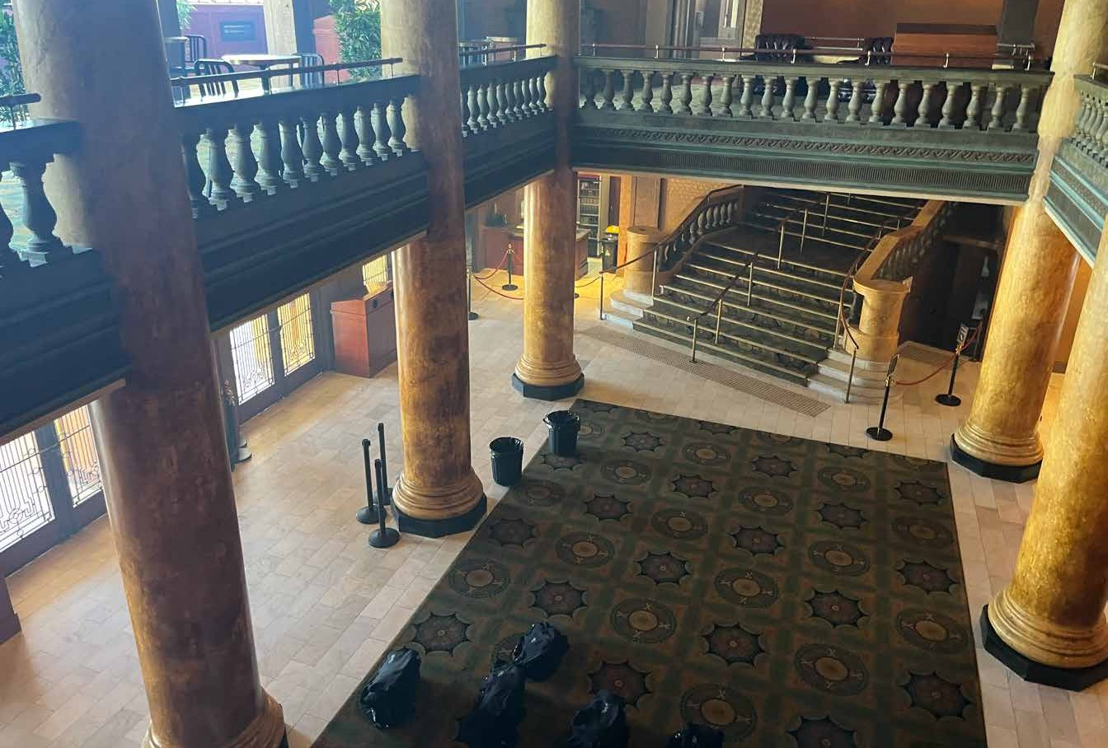
The Palais Theatre has two foyers that I can wait in for the show to start.
One foyer is on the ground floor, and one foyer is on level one.
I can get to level one by going up the stairs or using the elevator.

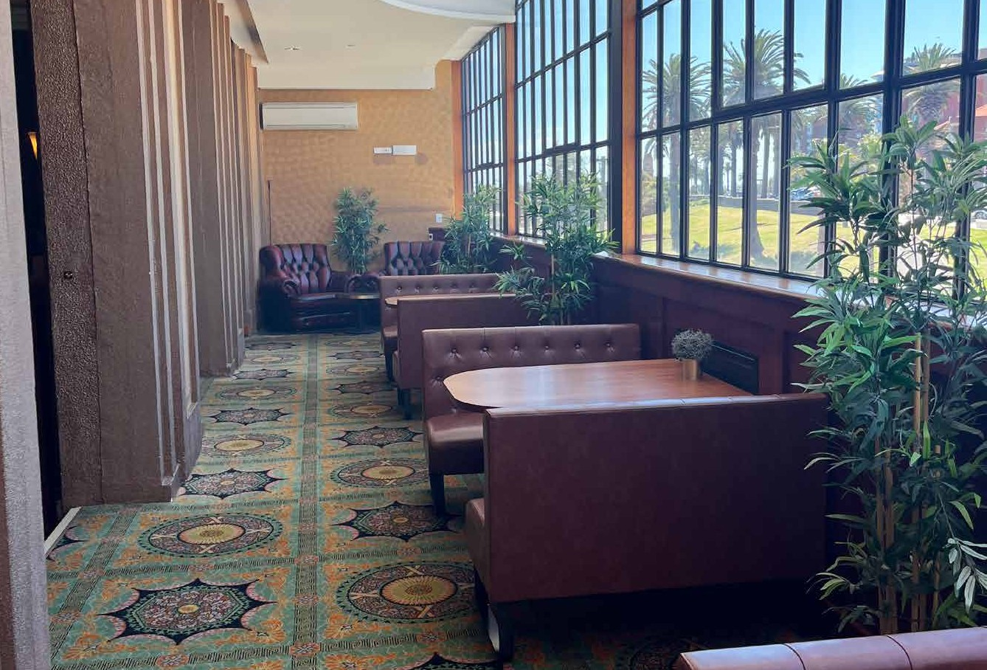
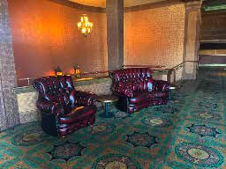
Theatre
There may be lots of other people in the foyer. It may be crowded and loud. There may be background music.
There are places on level one that I can sit down.

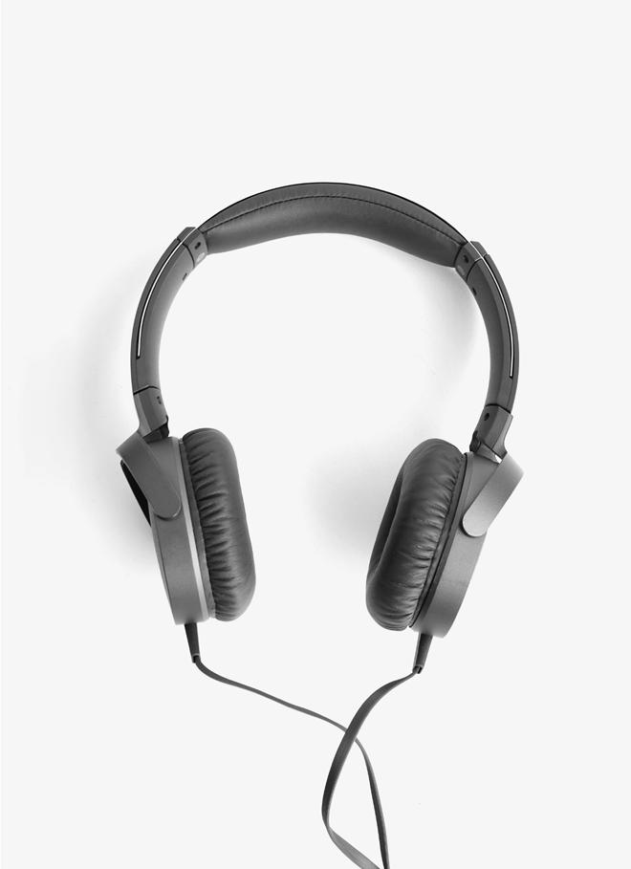
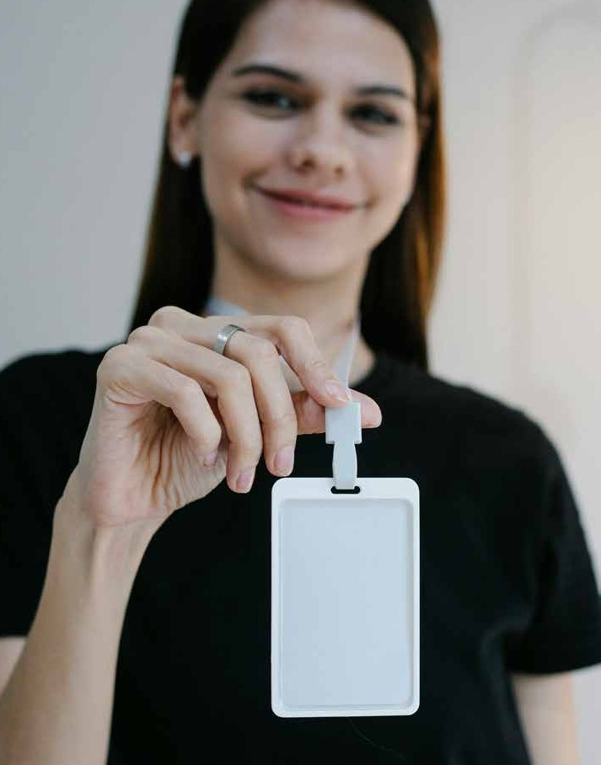
If I need help, I can talk to the staff members who will be wearing all black clothes and name tags.
I can bring headphones or ear plugs and wear them if it is too loud.

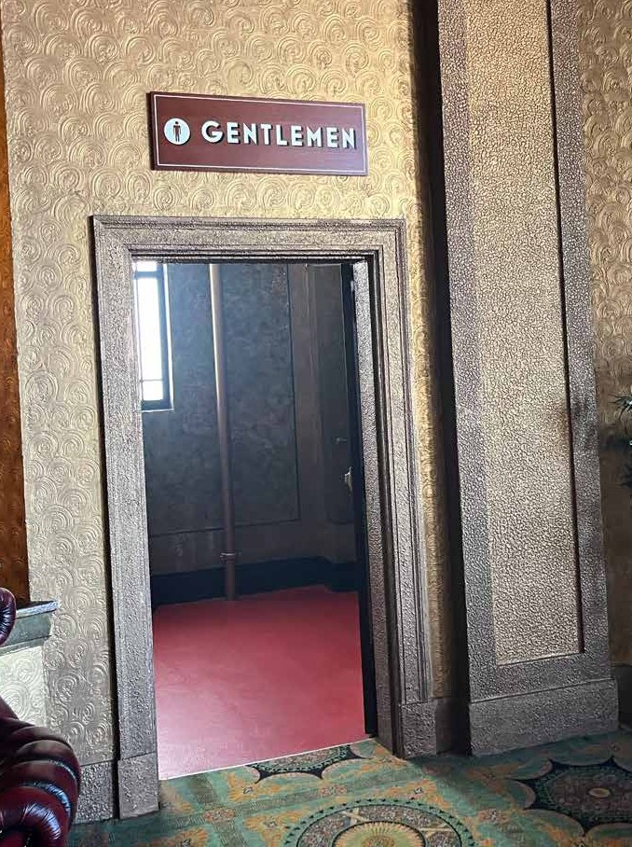
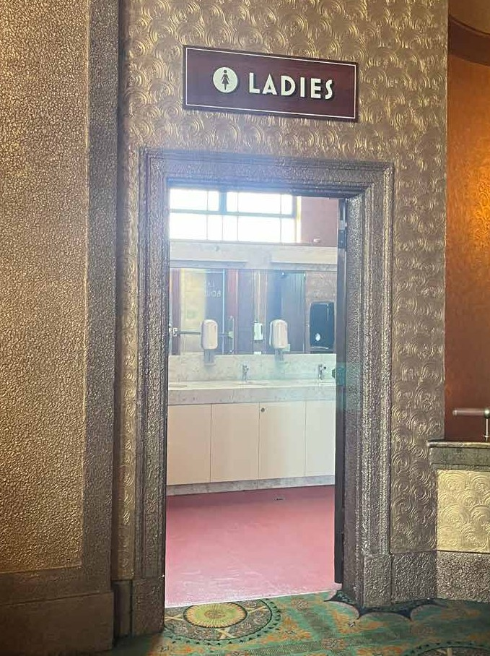
There are bathrooms on level one I can use if I need to.
I can access the bathrooms on level one by walking up the stairs, or using the elevator.

I can also ask a staff member to show me where they are.

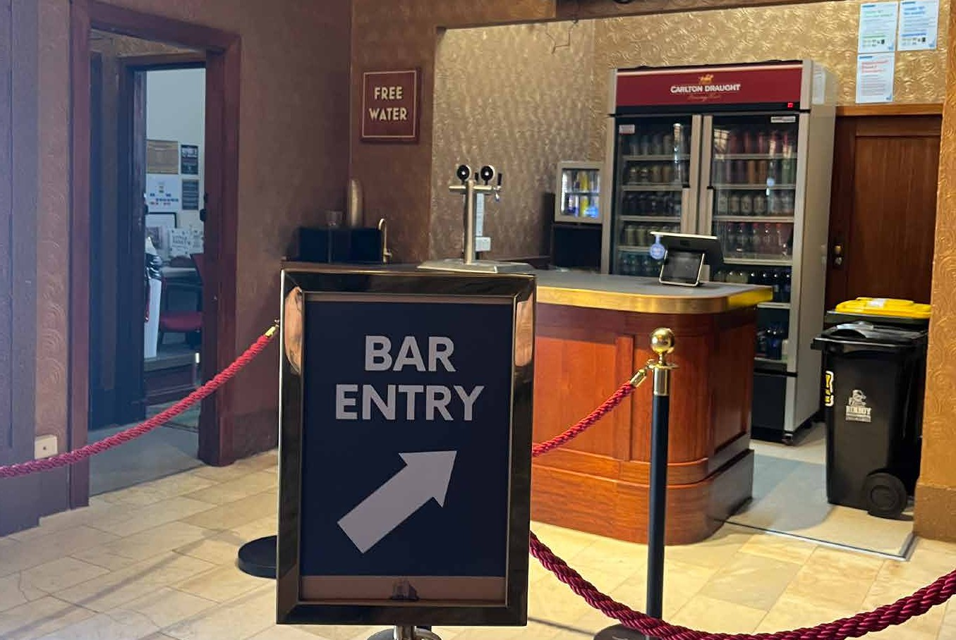
There is a bar on both levels that I can buy food and drinks from.
There will be alcoholic and non-alcoholic drinks.
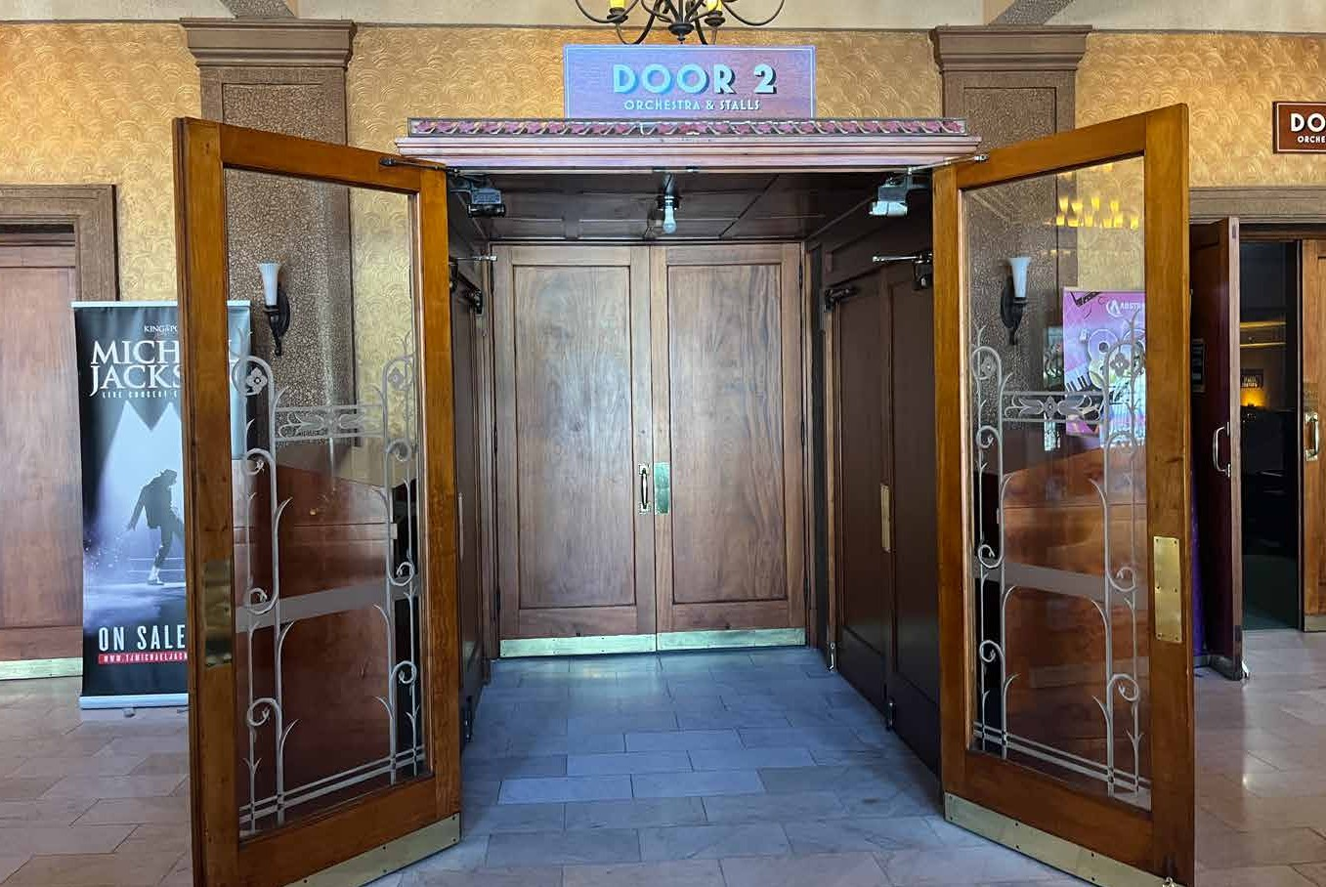
I can get water for free from beside the bar.

The doors to the theatre will open 30 minutes before the show starts.
There are two ways to enter the theatre. I can check my ticket or ask a staff member to see which level I need to enter from.
A staff member will check my ticket at the door, and tell me where my seat is.

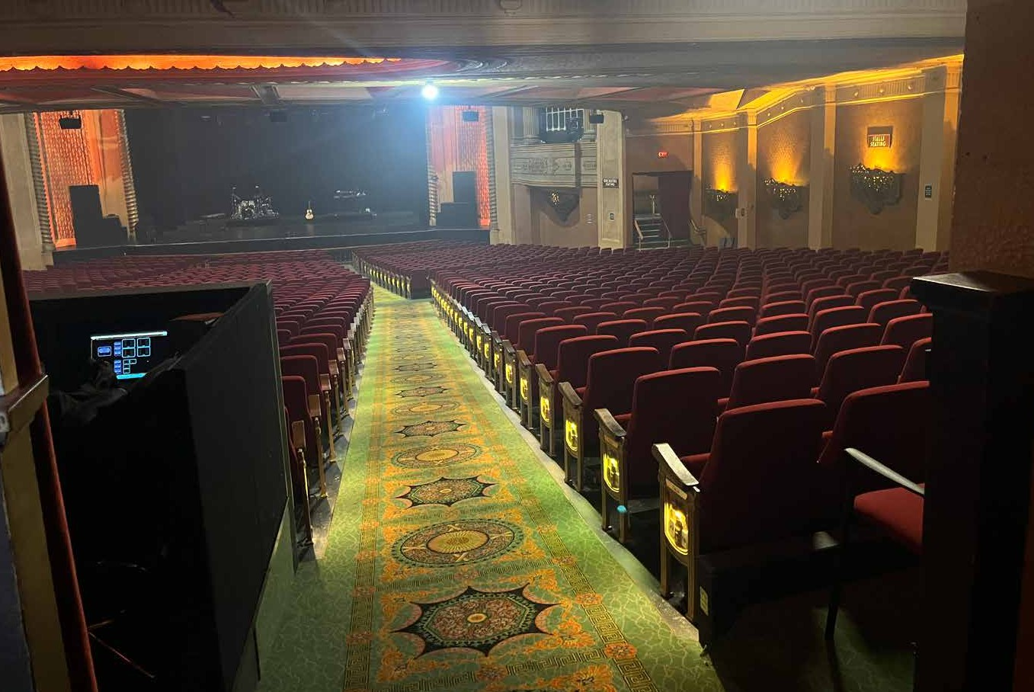
The theatre is in a big hall with lots of seats.
There will be background music playing, and people may be talking.
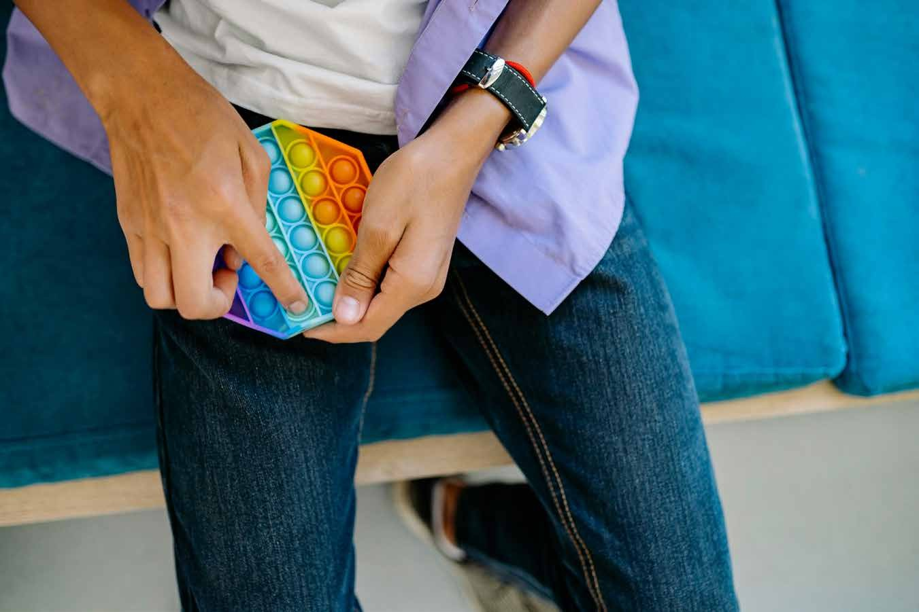
The stage will have a large set that may light up. There will be lots of lights that may shine towards me, and may move around.

I can bring a fidget toy to stim with if I need.
I will make sure it does not make loud noises, so that I don’t disturb anyone else watching the show.

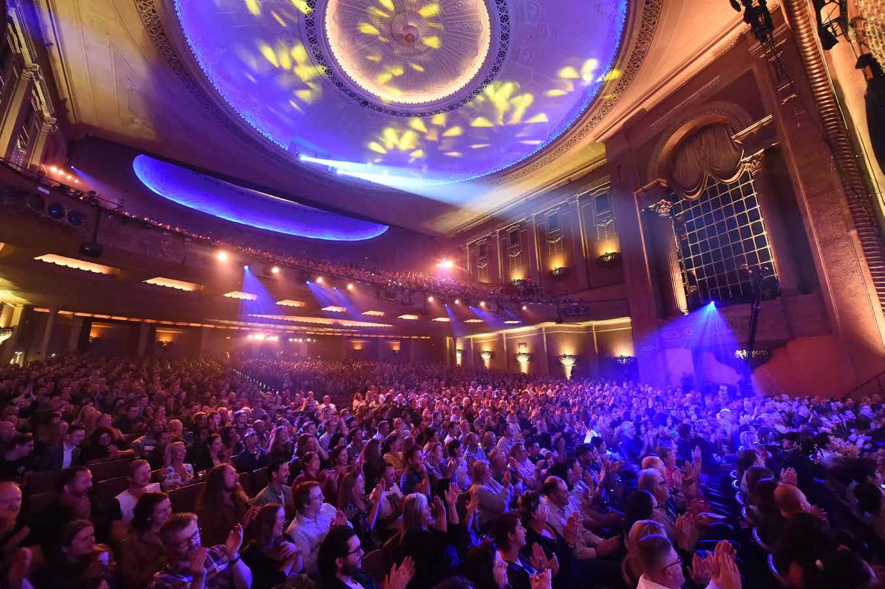
The performance will be recorded for television, so there will be large cameras.
There will also be a large crane with a camera on the end that moves around.
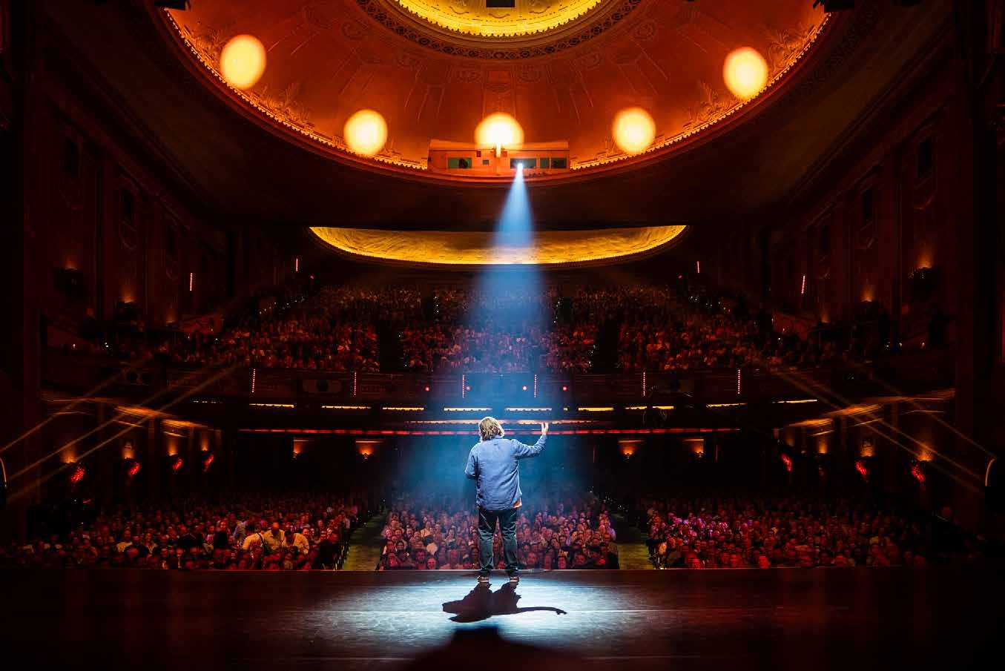
If being near the cameras or camera crane worries me, I can speak to an usher and ask them to find me another seat.

When the show is about to start, the ceiling lights will turn off, and it will get darker.
A warm-up act will come on stage and explain how the show will run. They may ask me to applaud and cheer with everyone else. This is so that the filming crew can get footage of people cheering.
If I’m unsure, I can sit still.

After the warm-up act finishes, the show will start.
Loud music will play, and the lights will flash and move around.
The host will come out to start the show, and people will clap. They will tell some jokes, and then introduce the next act.

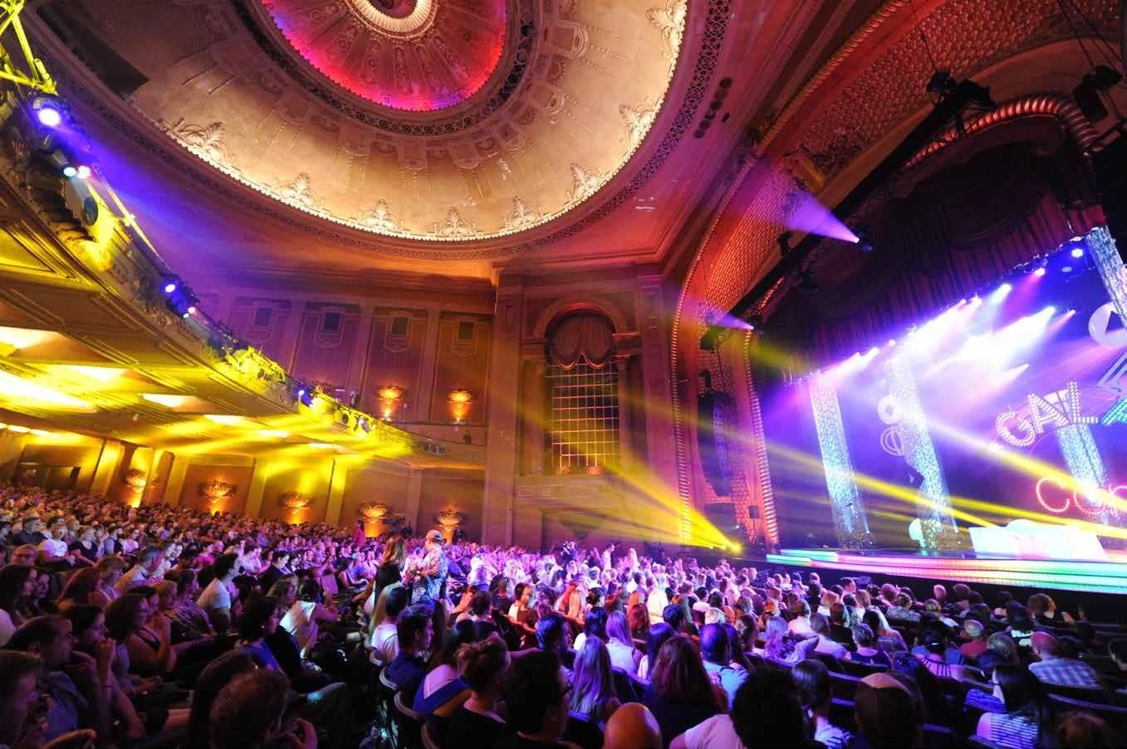
Throughout the show, I will see lots of different performers.
They will all tell different kinds of jokes, and people will laugh and clap. I can laugh and clap as well if I want too.

I may recognise some performers, and I may discover some new performers.

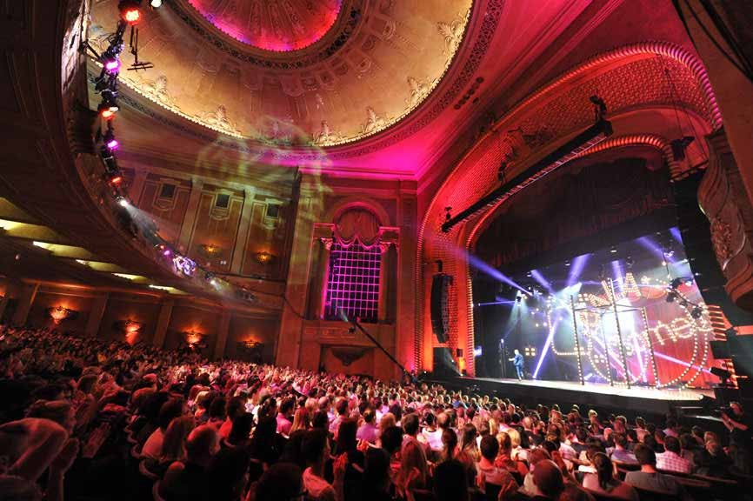
There will be a break in the middle of the performance called an intermission.
The ceiling lights will come on during the intermission, and I can get out of my seat and go to the toilet or to the bar.
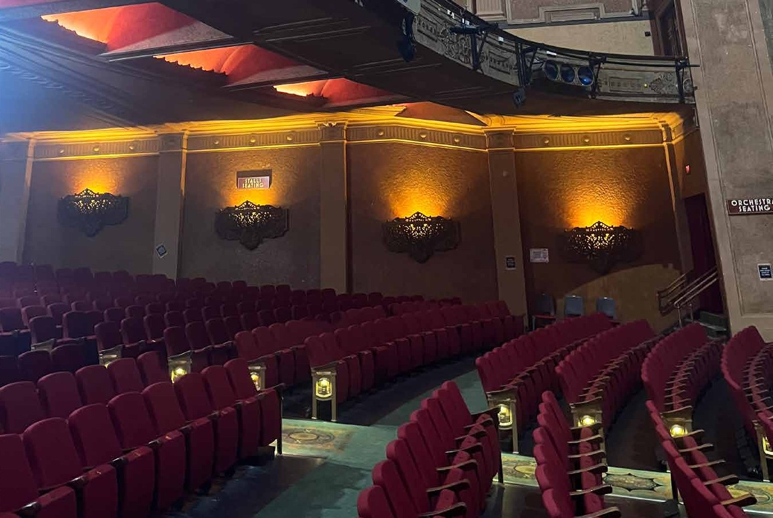
There will be an announcement over the speakers when the intermission is over, and I should go back to my seat.

At the end of the show, the ceiling lights will come on, and it will be time to leave.
There will be lots of other people leaving at the same time as me.

